CHAPTER SEVEN
RESULTS AND VALIDATION ASSESSMENT
Evaluation and Deployment of 3D-Printed Automatic Weather Stations (3D-PAWS) in Kenya with Integrated Data Visualization and Monitoring Systems
Station: GARISSA
KMD Reference Station: GARISSA METEOROLOGICAL STATION
Validation Period: 2024-08_to_2026-05

This chapter presents the results of the comparative validation assessment between the 3D-PAWS station observations and corresponding Kenya Meteorological Department (KMD) reference observations. The assessment evaluates the performance of temperature, relative humidity, atmospheric pressure, and rainfall observations using statistical analysis, quality assessment, and graphical comparison methods implemented within the 3D-PAWS Validation Toolkit.

7.1 Overview of the Results
The validation assessment was conducted for GARISSA using GARISSA METEOROLOGICAL STATION as the Kenya Meteorological Department (KMD) reference station. The evaluation period extended from 2024-08-12 to 2026-05-15, representing a validation period of 642 days.
The assessment evaluated the performance of 3D-PAWS observations against KMD reference measurements for key meteorological variables including temperature, relative humidity, atmospheric pressure, and rainfall. The validation process included dataset standardization, observation-period alignment, quality assessment, statistical evaluation, and graphical comparison using the developed 3D-PAWS Validation Toolkit.
The analysis generated 11 parameter-level validation results. 11 parameters received formal performance assessments based on statistical criteria, while 0 parameters were not formally assessed due to limitations related to data availability, quality control filtering, or insufficient paired observations.
The results presented in this chapter provide an evaluation of the suitability of locally fabricated 3D-PAWS systems for meteorological observation network densification and support the assessment of their potential for operational deployment.
3D-PAWS Station | GARISSA
KMD Reference Station | GARISSA METEOROLOGICAL STATION
Validation Period | 2024-08_to_2026-05
Observation Start | 2024-08-12
Observation End | 2026-05-15
Validation Days | 642
Parameters Evaluated | 11
Parameters Assessed | 11
Parameters Not Assessed | 0

7.2 Dataset Availability, Completeness and Quality Assessment
This section presents the availability, completeness, and quality assessment of observations used for the validation exercise. Sensor-level quality information from the 3D-PAWS system is presented separately from daily validation coverage used for comparison with the Kenya Meteorological Department (KMD) reference dataset.

7.2.1 3D-PAWS Sensor Data Quality Assessment
Parameter | Sensor | Observations | Valid | Validity (%) | QC Flags | Missing | Quality Level
Temperature | mt1 | 841190 | 841190 | 100.00% | 0 | 0 | HIGH QUALITY
Humidity | sh1 | 841190 | 841190 | 100.00% | 0 | 0 | HIGH QUALITY
Pressure | bp1 | 841190 | 832538 | 98.97% | 0 | 8652 | GOOD QUALITY
Sensor-level quality control was performed using the variable-specific validation rules implemented in the 3D-PAWS Validation Toolkit. Valid observations were retained for statistical evaluation, while quality-flagged observations were identified and handled separately. For rainfall variables, zero observations were retained as valid measurements because they represent actual dry conditions rather than missing data.

7.2.2 Daily Validation Coverage
Parameter | Paired Days | Missing Days | Coverage (%)
Maximum Temperature | 580 | 62 | 90.3%
Minimum Temperature | 585 | 57 | 91.1%
Mean Temperature | 570 | 72 | 88.8%
Maximum Relative Humidity | 565 | 77 | 88.0%
Minimum Relative Humidity | 565 | 77 | 88.0%
Mean Relative Humidity | 565 | 77 | 88.0%
Maximum Pressure | 567 | 75 | 88.3%
Minimum Pressure | 567 | 75 | 88.3%
Mean Pressure | 567 | 75 | 88.3%
Daily Rainfall (Rain Gauge 1) | 636 | 6 | 99.1%
Daily Rainfall (Rain Gauge 2) | 636 | 6 | 99.1%
Daily validation coverage represents the proportion of observations where 3D-PAWS and KMD measurements were available for direct comparison. Differences in coverage may result from data availability, quality-control filtering, and differences in daily record completeness. Statistical performance metrics were calculated only using paired observations within the common validation period.
The validation assessment included 11 meteorological parameters. Parameter-specific coverage values were considered during interpretation to ensure that reported statistics represent available paired observations.

7.3 Validation Statistics and Performance Assessment
The validation assessment compares paired 3D-PAWS and Kenya Meteorological Department (KMD) observations within the common validation period. Statistical performance metrics were calculated using observations available from both systems after the applicable quality-control and data-availability procedures.

7.3.1 Statistical Performance Indicators
The comparison uses several complementary statistical indicators to evaluate agreement between 3D-PAWS and KMD observations. Bias indicates the mean systematic difference between the two observation systems. Mean Absolute Error (MAE) represents the average magnitude of the absolute differences, while Root Mean Square Error (RMSE) gives greater weight to larger differences.
The correlation coefficient (r) is used to evaluate the strength of the linear temporal relationship between 3D-PAWS and KMD observations. The coefficient of determination (R²) indicates the proportion of variance in the KMD observations that is explained by the corresponding 3D-PAWS observations.

7.3.2 Performance Classification
Performance classification was based on the parameter-specific criteria implemented in the 3D-PAWS Validation Toolkit. Where WMO requirement criteria were available, the assessment considers the Goal, Breakthrough, and Threshold levels associated with the relevant meteorological parameter.
A parameter classified as Threshold met the implemented Threshold criterion for the corresponding performance measure. Parameters classified as Below Threshold did not meet the implemented Threshold criterion. Such classification is interpreted together with correlation, bias, MAE, RMSE, observation coverage, and the intended operational application of the parameter.

7.3.3 Interpretation of Statistical Agreement
Statistical indicators are interpreted collectively rather than using a single metric in isolation. Strong correlation indicates that the 3D-PAWS system follows the temporal variability observed by the KMD reference system, while bias and error statistics indicate the degree of numerical agreement between the two datasets.
Differences between the two observation systems may also reflect sensor characteristics, calibration, station exposure, elevation effects, precipitation spatial variability, and differences in measurement procedures. Consequently, statistical classifications are considered together with the physical and operational characteristics of each parameter.

7.4 Temperature Results

Maximum Temperature
Data status: HIGH QUALITY | Paired observations: 580 | Comparison missing: 62
Descriptive statistics
Statistic | 3DPAWS | KMD
Observations | 580 | 580
Mean | 35.486 | 35.049
Median | 35.600 | 35.185
Minimum | 29.600 | 28.200
Maximum | 40.100 | 39.800
Standard Deviation | 1.868 | 1.830
Variance | 3.488 | 3.350
Validation statistics
Metric | Value
Bias | 0.437 °C
Mean Absolute Error (MAE) | 0.506 °C
Root Mean Square Error (RMSE) | 0.776 °C
Correlation coefficient (r) | 0.940
Coefficient of determination (R²) | 0.883
Performance assessment: Breakthrough
WMO requirement: 253
Criterion | Value
Goal | 0.500 °C
Breakthrough | 1.000 °C
Threshold | 2.000 °C
Interpretation: The paired observations show very strong linear agreement between 3DPAWS and KMD measurements (r = 0.940). The coefficient of determination was R² = 0.883. The mean bias was 0.437 °C, indicating that the 3DPAWS observations were generally higher than the KMD observations. The mean absolute error was 0.506 °C. The root mean square error was 0.776 °C. Under the implemented performance assessment criteria, the parameter was classified as Breakthrough.
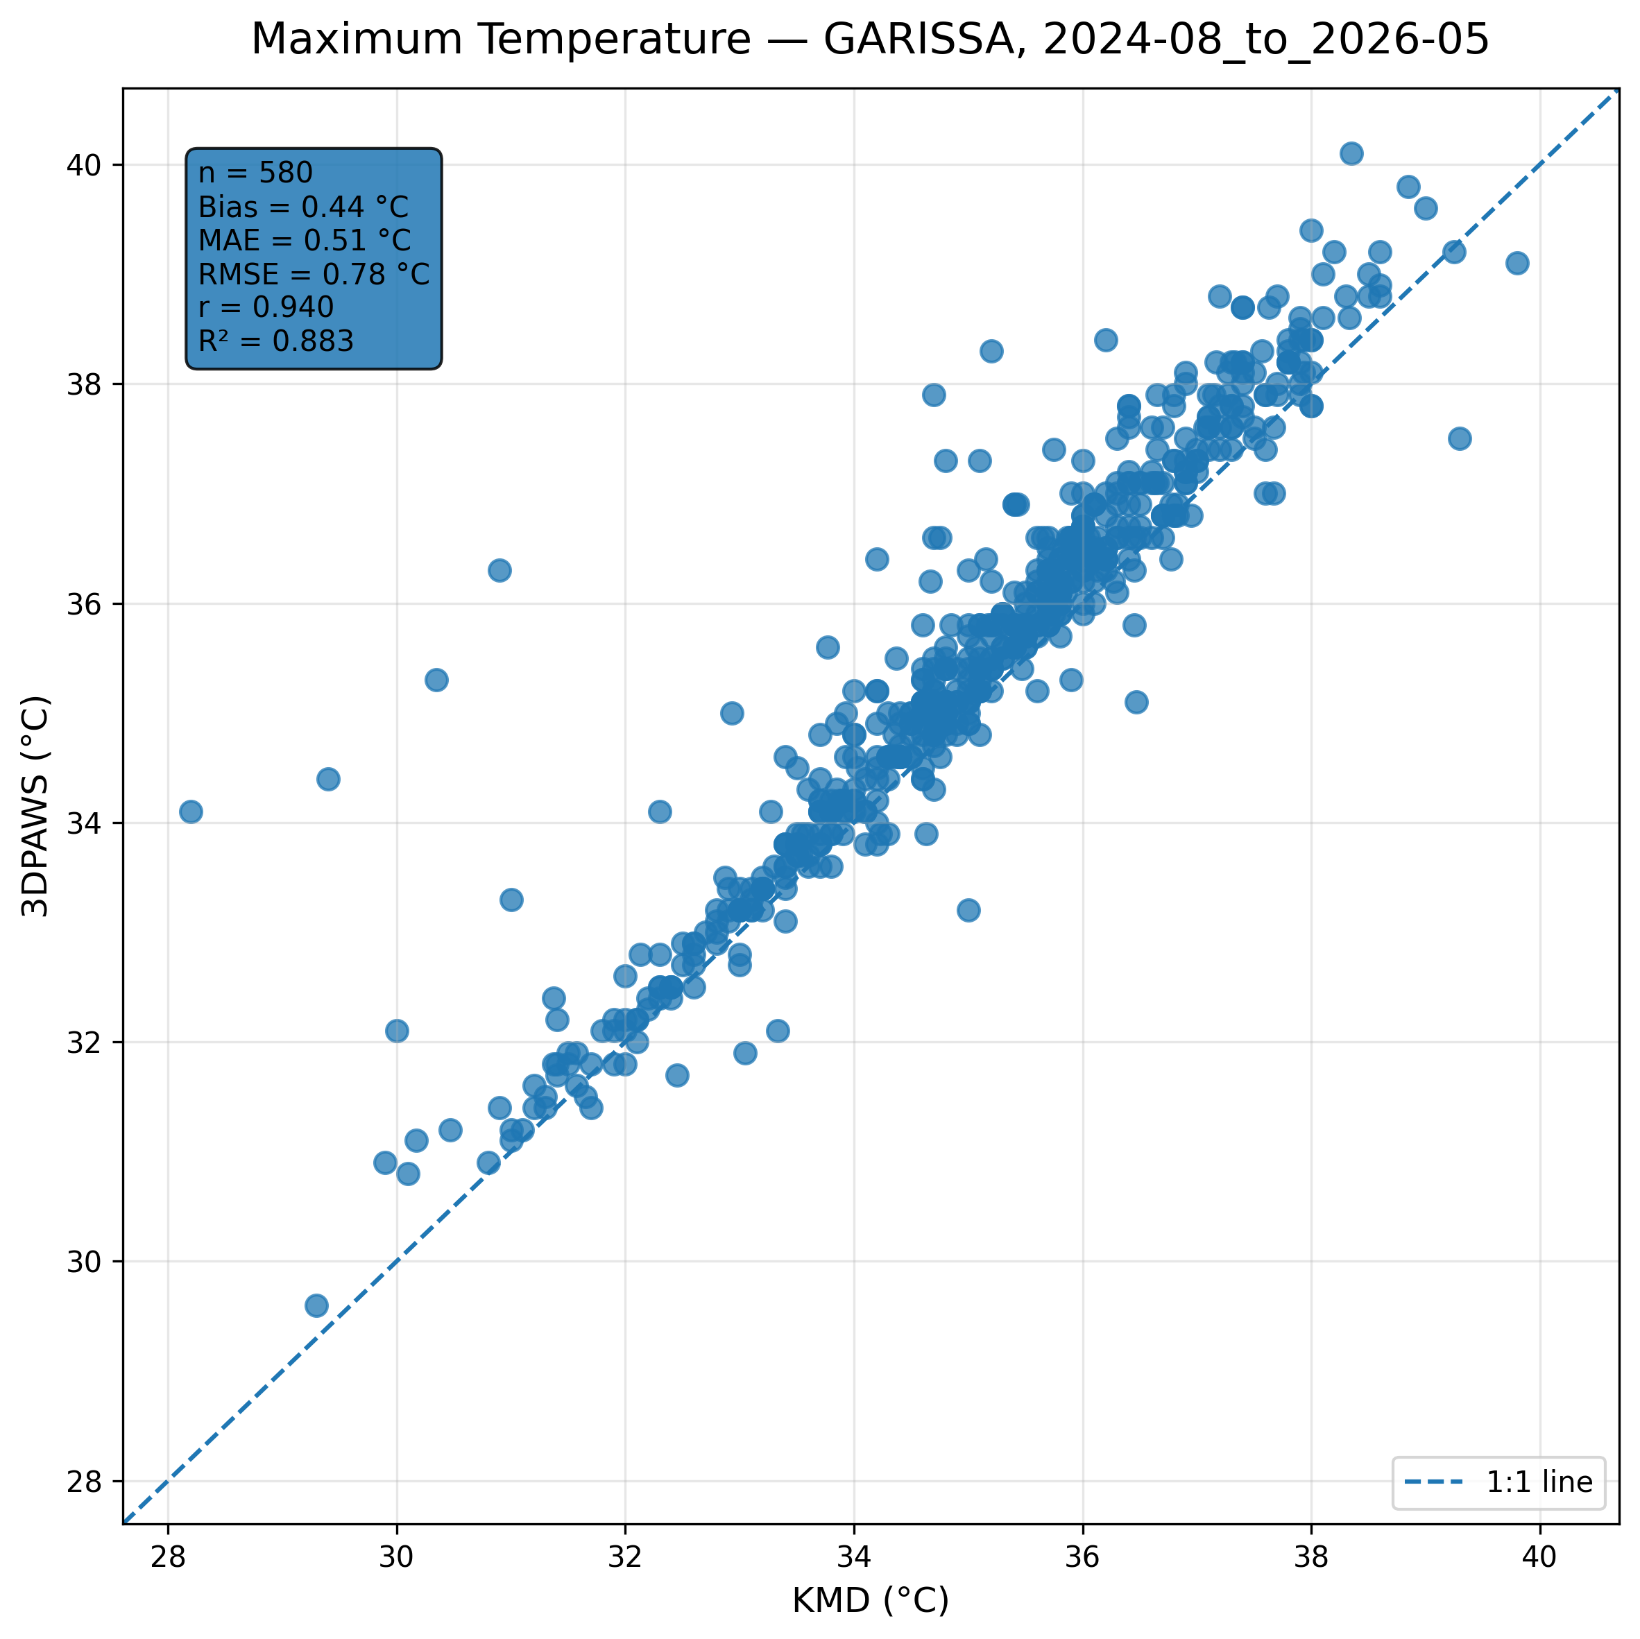
Figure 7.1: Scatter comparison of maximum temperature observations between 3DPAWS and KMD at GARISSA for 2024-08_to_2026-05.
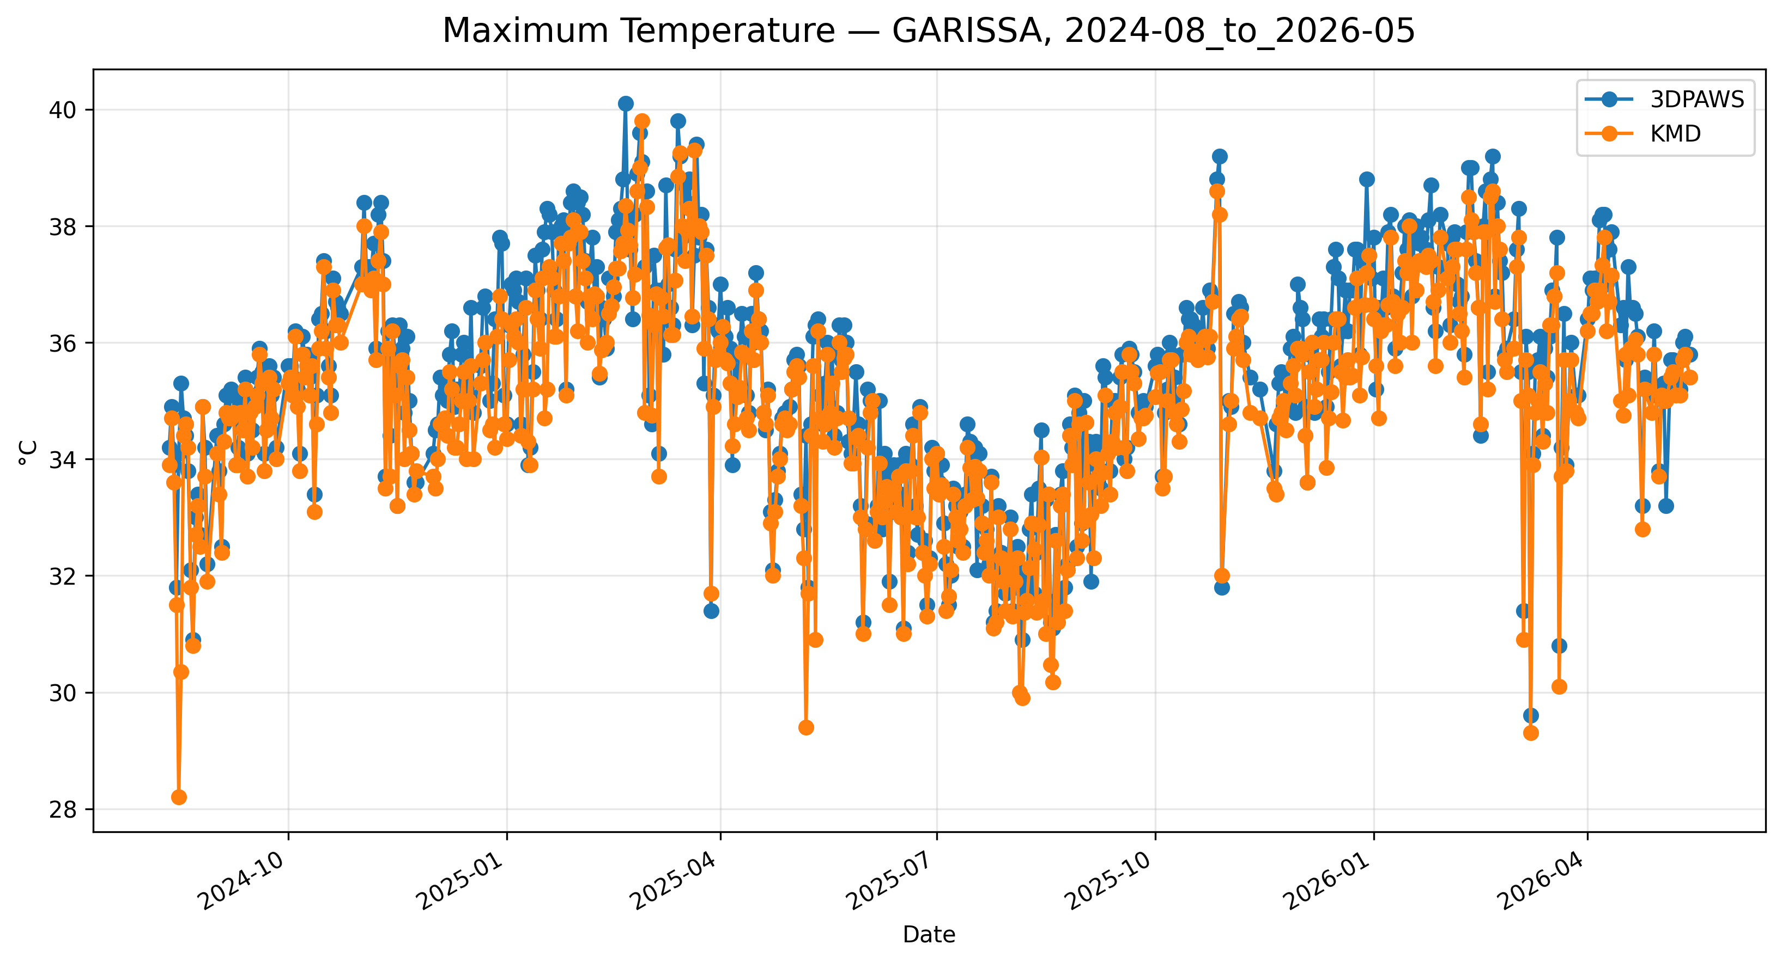
Figure 7.2: Time-series comparison of daily maximum temperature observations between 3DPAWS and KMD at GARISSA for 2024-08_to_2026-05.

Minimum Temperature
Data status: HIGH QUALITY | Paired observations: 585 | Comparison missing: 57
Descriptive statistics
Statistic | 3DPAWS | KMD
Observations | 585 | 585
Mean | 23.965 | 24.524
Median | 24.000 | 24.600
Minimum | 19.400 | 19.000
Maximum | 29.600 | 27.570
Standard Deviation | 1.352 | 1.260
Variance | 1.827 | 1.588
Validation statistics
Metric | Value
Bias | -0.560 °C
Mean Absolute Error (MAE) | 0.717 °C
Root Mean Square Error (RMSE) | 0.967 °C
Correlation coefficient (r) | 0.820
Coefficient of determination (R²) | 0.672
Performance assessment: Breakthrough
WMO requirement: 253
Criterion | Value
Goal | 0.500 °C
Breakthrough | 1.000 °C
Threshold | 2.000 °C
Interpretation: The paired observations show strong linear agreement between 3DPAWS and KMD measurements (r = 0.820). The coefficient of determination was R² = 0.672. The mean bias was -0.560 °C, indicating that the 3DPAWS observations were generally lower than the KMD observations. The mean absolute error was 0.717 °C. The root mean square error was 0.967 °C. Under the implemented performance assessment criteria, the parameter was classified as Breakthrough.
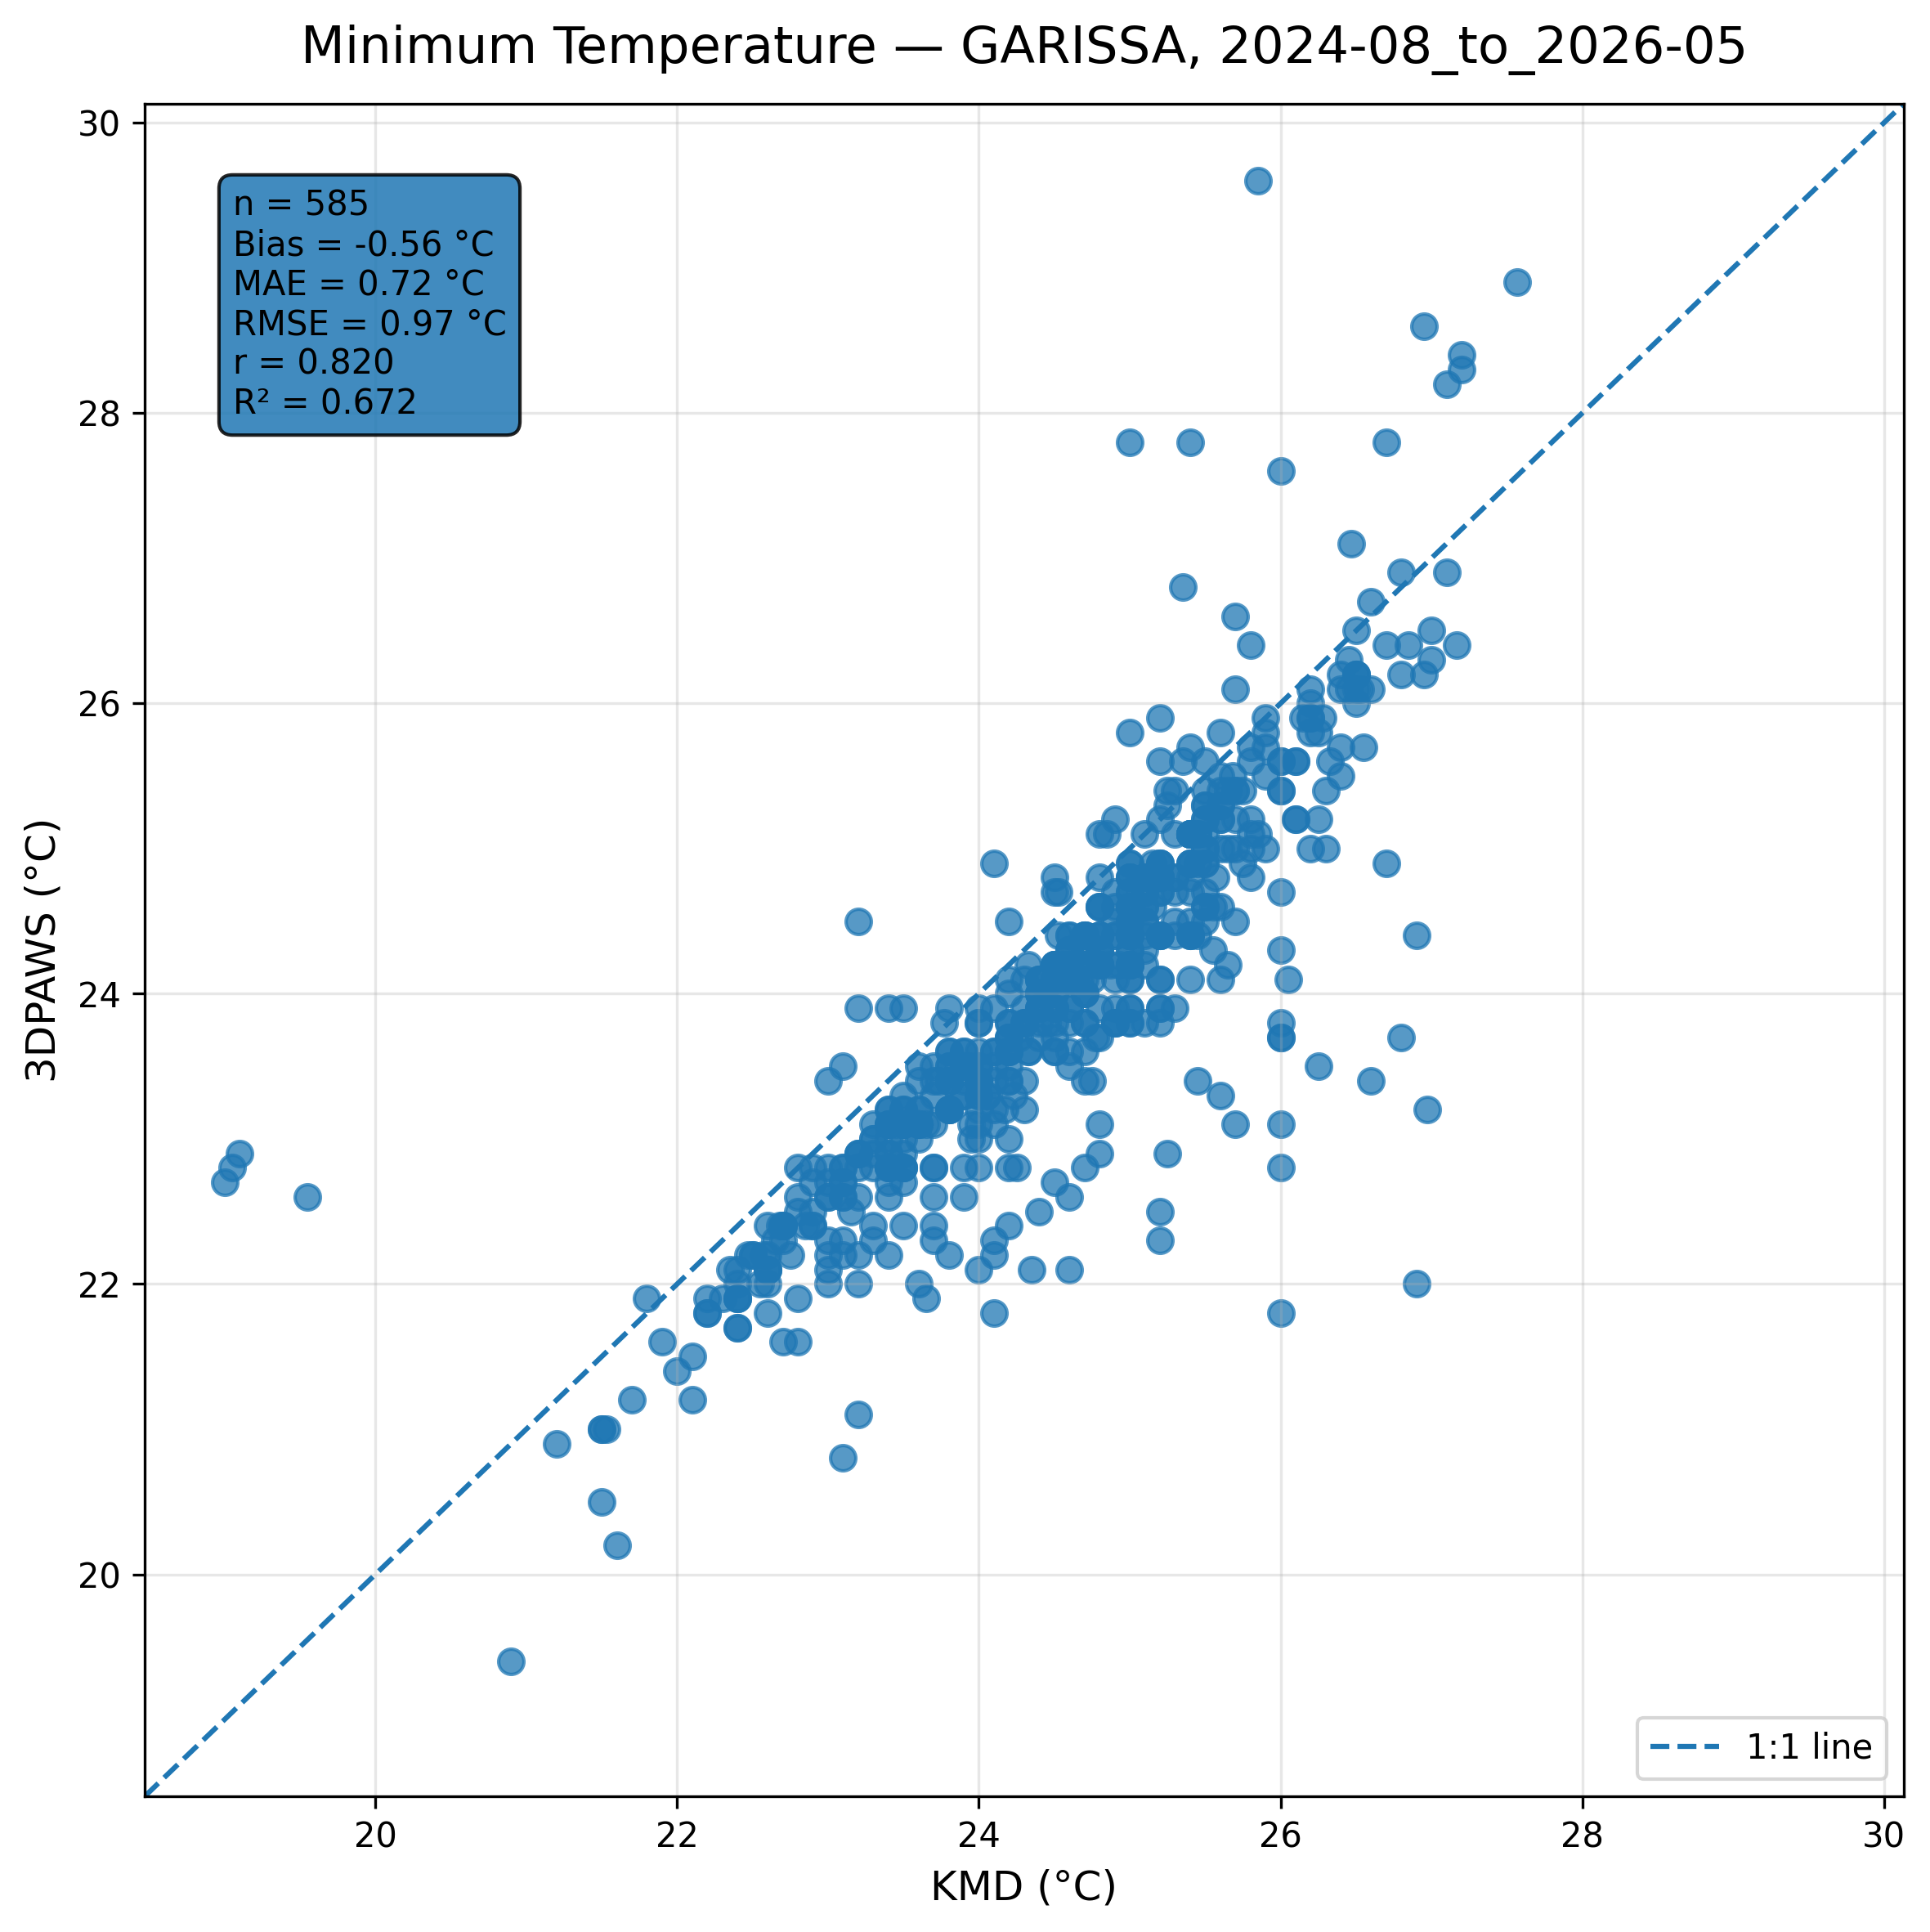
Figure 7.3: Scatter comparison of minimum temperature observations between 3DPAWS and KMD at GARISSA for 2024-08_to_2026-05.
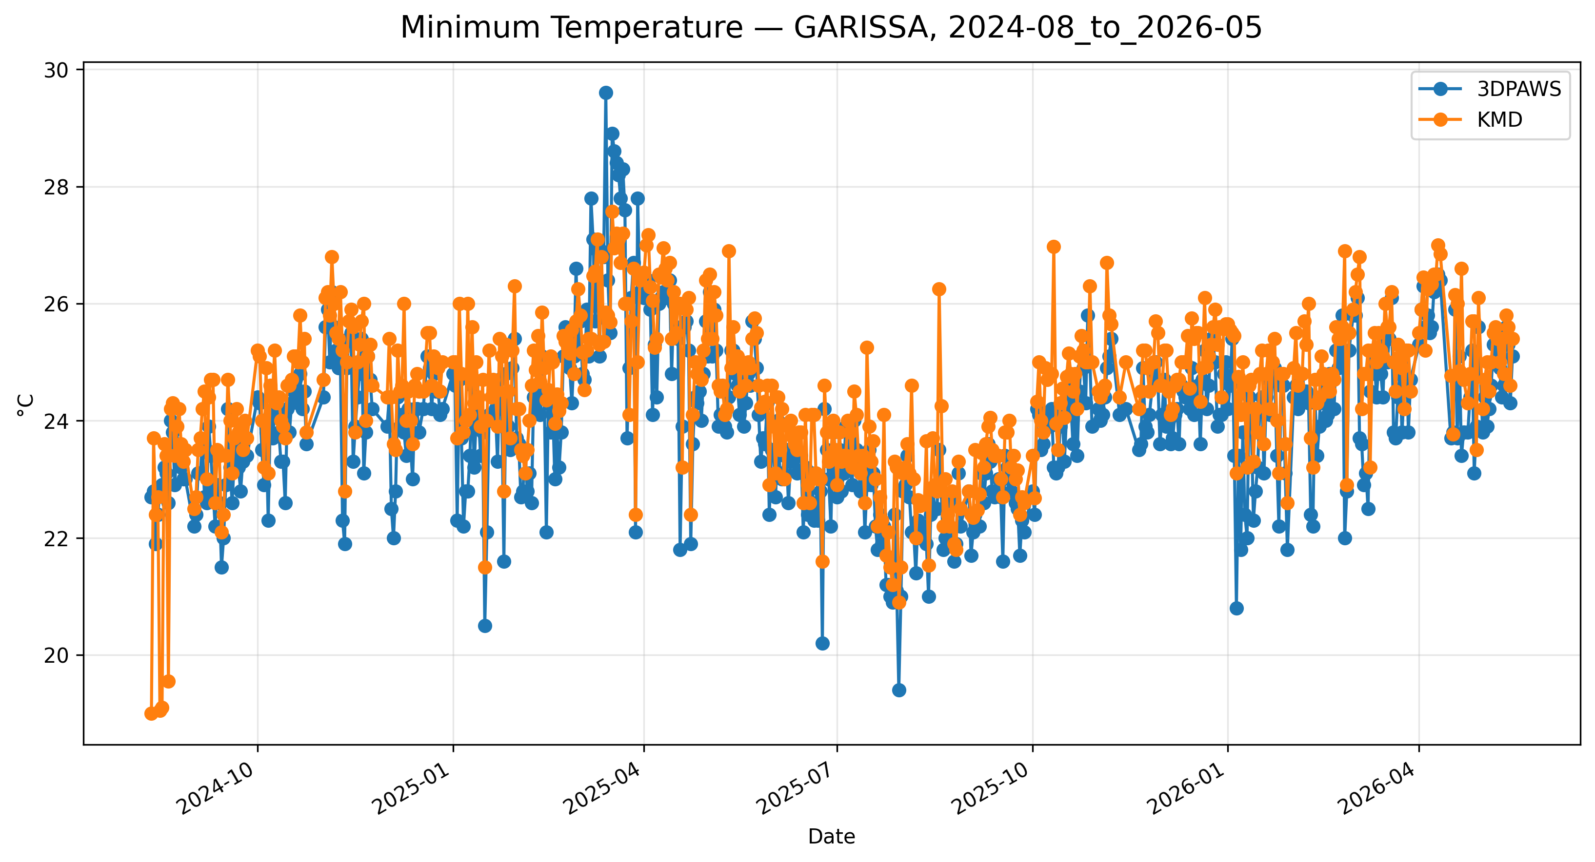
Figure 7.4: Time-series comparison of daily minimum temperature observations between 3DPAWS and KMD at GARISSA for 2024-08_to_2026-05.

Mean Temperature
Data status: HIGH QUALITY | Paired observations: 570 | Comparison missing: 72
Descriptive statistics
Statistic | 3DPAWS | KMD
Observations | 570 | 570
Mean | 28.978 | 29.782
Median | 29.022 | 29.950
Minimum | 25.251 | 23.625
Maximum | 35.344 | 33.000
Standard Deviation | 1.552 | 1.349
Variance | 2.408 | 1.819
Validation statistics
Metric | Value
Bias | -0.804 °C
Mean Absolute Error (MAE) | 0.993 °C
Root Mean Square Error (RMSE) | 1.135 °C
Correlation coefficient (r) | 0.856
Coefficient of determination (R²) | 0.733
Performance assessment: Threshold
WMO requirement: 253
Criterion | Value
Goal | 0.500 °C
Breakthrough | 1.000 °C
Threshold | 2.000 °C
Interpretation: The paired observations show strong linear agreement between 3DPAWS and KMD measurements (r = 0.856). The coefficient of determination was R² = 0.733. The mean bias was -0.804 °C, indicating that the 3DPAWS observations were generally lower than the KMD observations. The mean absolute error was 0.993 °C. The root mean square error was 1.135 °C. Under the implemented performance assessment criteria, the parameter was classified as Threshold.
Figure 7.5: Scatter comparison of mean temperature observations between 3DPAWS and KMD at GARISSA for 2024-08_to_2026-05.
Figure 7.6: Time-series comparison of daily mean temperature observations between 3DPAWS and KMD at GARISSA for 2024-08_to_2026-05.

7.5 Relative Humidity Results

Maximum Relative Humidity
Data status: HIGH QUALITY | Paired observations: 565 | Comparison missing: 77
Descriptive statistics
Statistic | 3DPAWS | KMD
Observations | 565 | 565
Mean | 83.629 | 49.150
Median | 82.800 | 48.200
Minimum | 66.700 | 27.170
Maximum | 96.600 | 82.280
Standard Deviation | 5.404 | 7.273
Variance | 29.203 | 52.897
Validation statistics
Metric | Value
Bias | 34.479 %
Mean Absolute Error (MAE) | 34.479 %
Root Mean Square Error (RMSE) | 34.903 %
Correlation coefficient (r) | 0.670
Coefficient of determination (R²) | 0.448
Performance assessment: Below Threshold
WMO requirement: 776
Criterion | Value
Goal | 0.500 %
Breakthrough | 2.500 %
Threshold | 5.000 %
Interpretation: The paired observations show moderate linear agreement between 3DPAWS and KMD measurements (r = 0.670). The coefficient of determination was R² = 0.448. The mean bias was 34.479 %, indicating that the 3DPAWS observations were generally higher than the KMD observations. The mean absolute error was 34.479 %. The root mean square error was 34.903 %. Under the implemented performance assessment criteria, the parameter was classified as Below Threshold. The relatively high correlation indicates that 3D-PAWS successfully captured temporal humidity variability despite differences in absolute values.
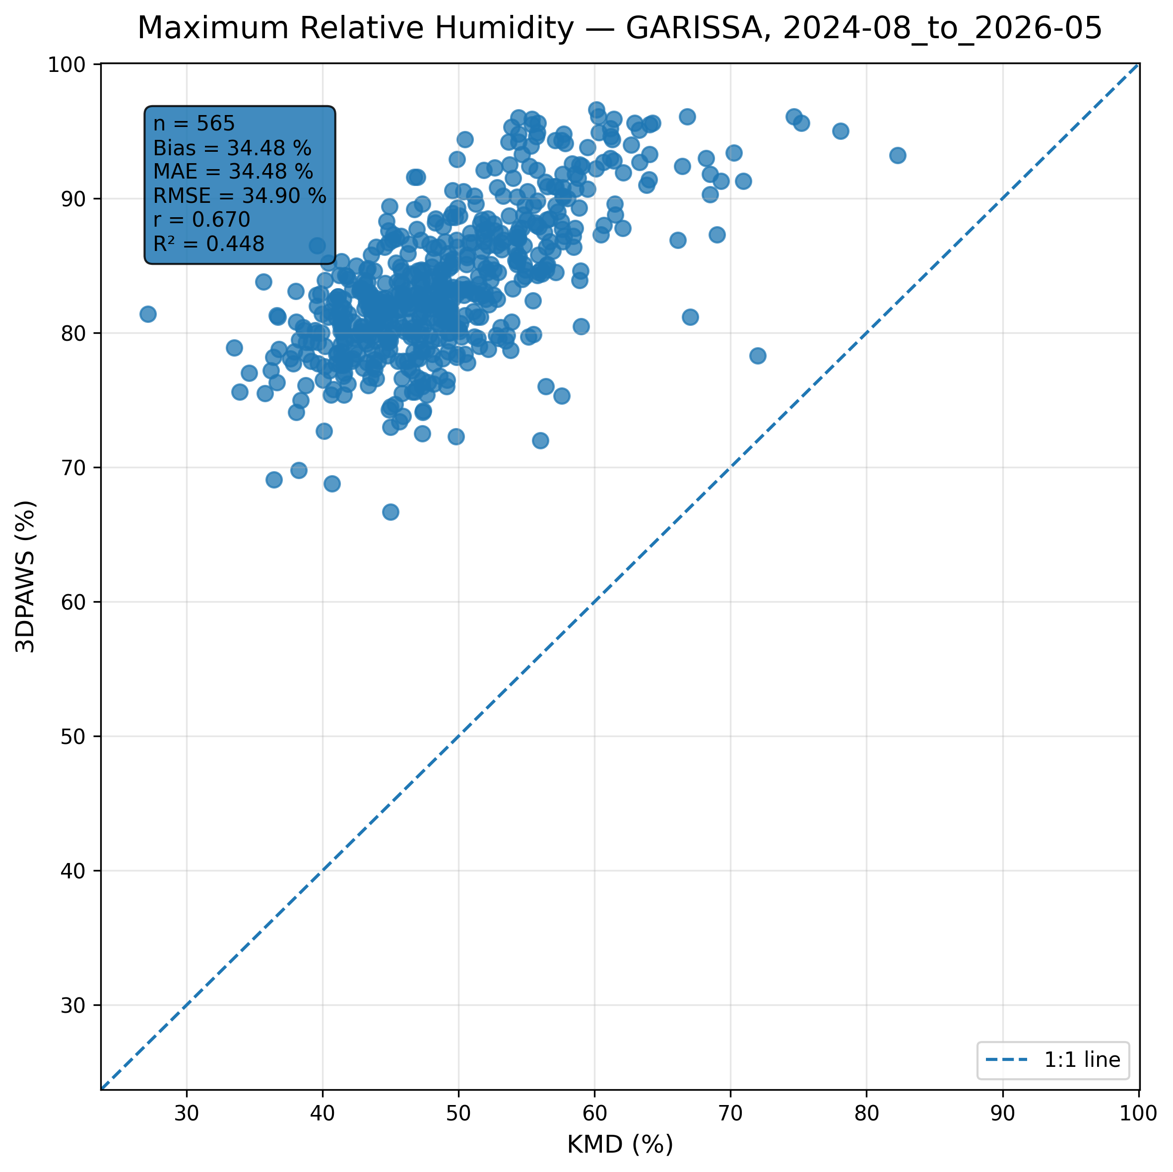
Figure 7.7: Scatter comparison of maximum relative humidity observations between 3DPAWS and KMD at GARISSA for 2024-08_to_2026-05.
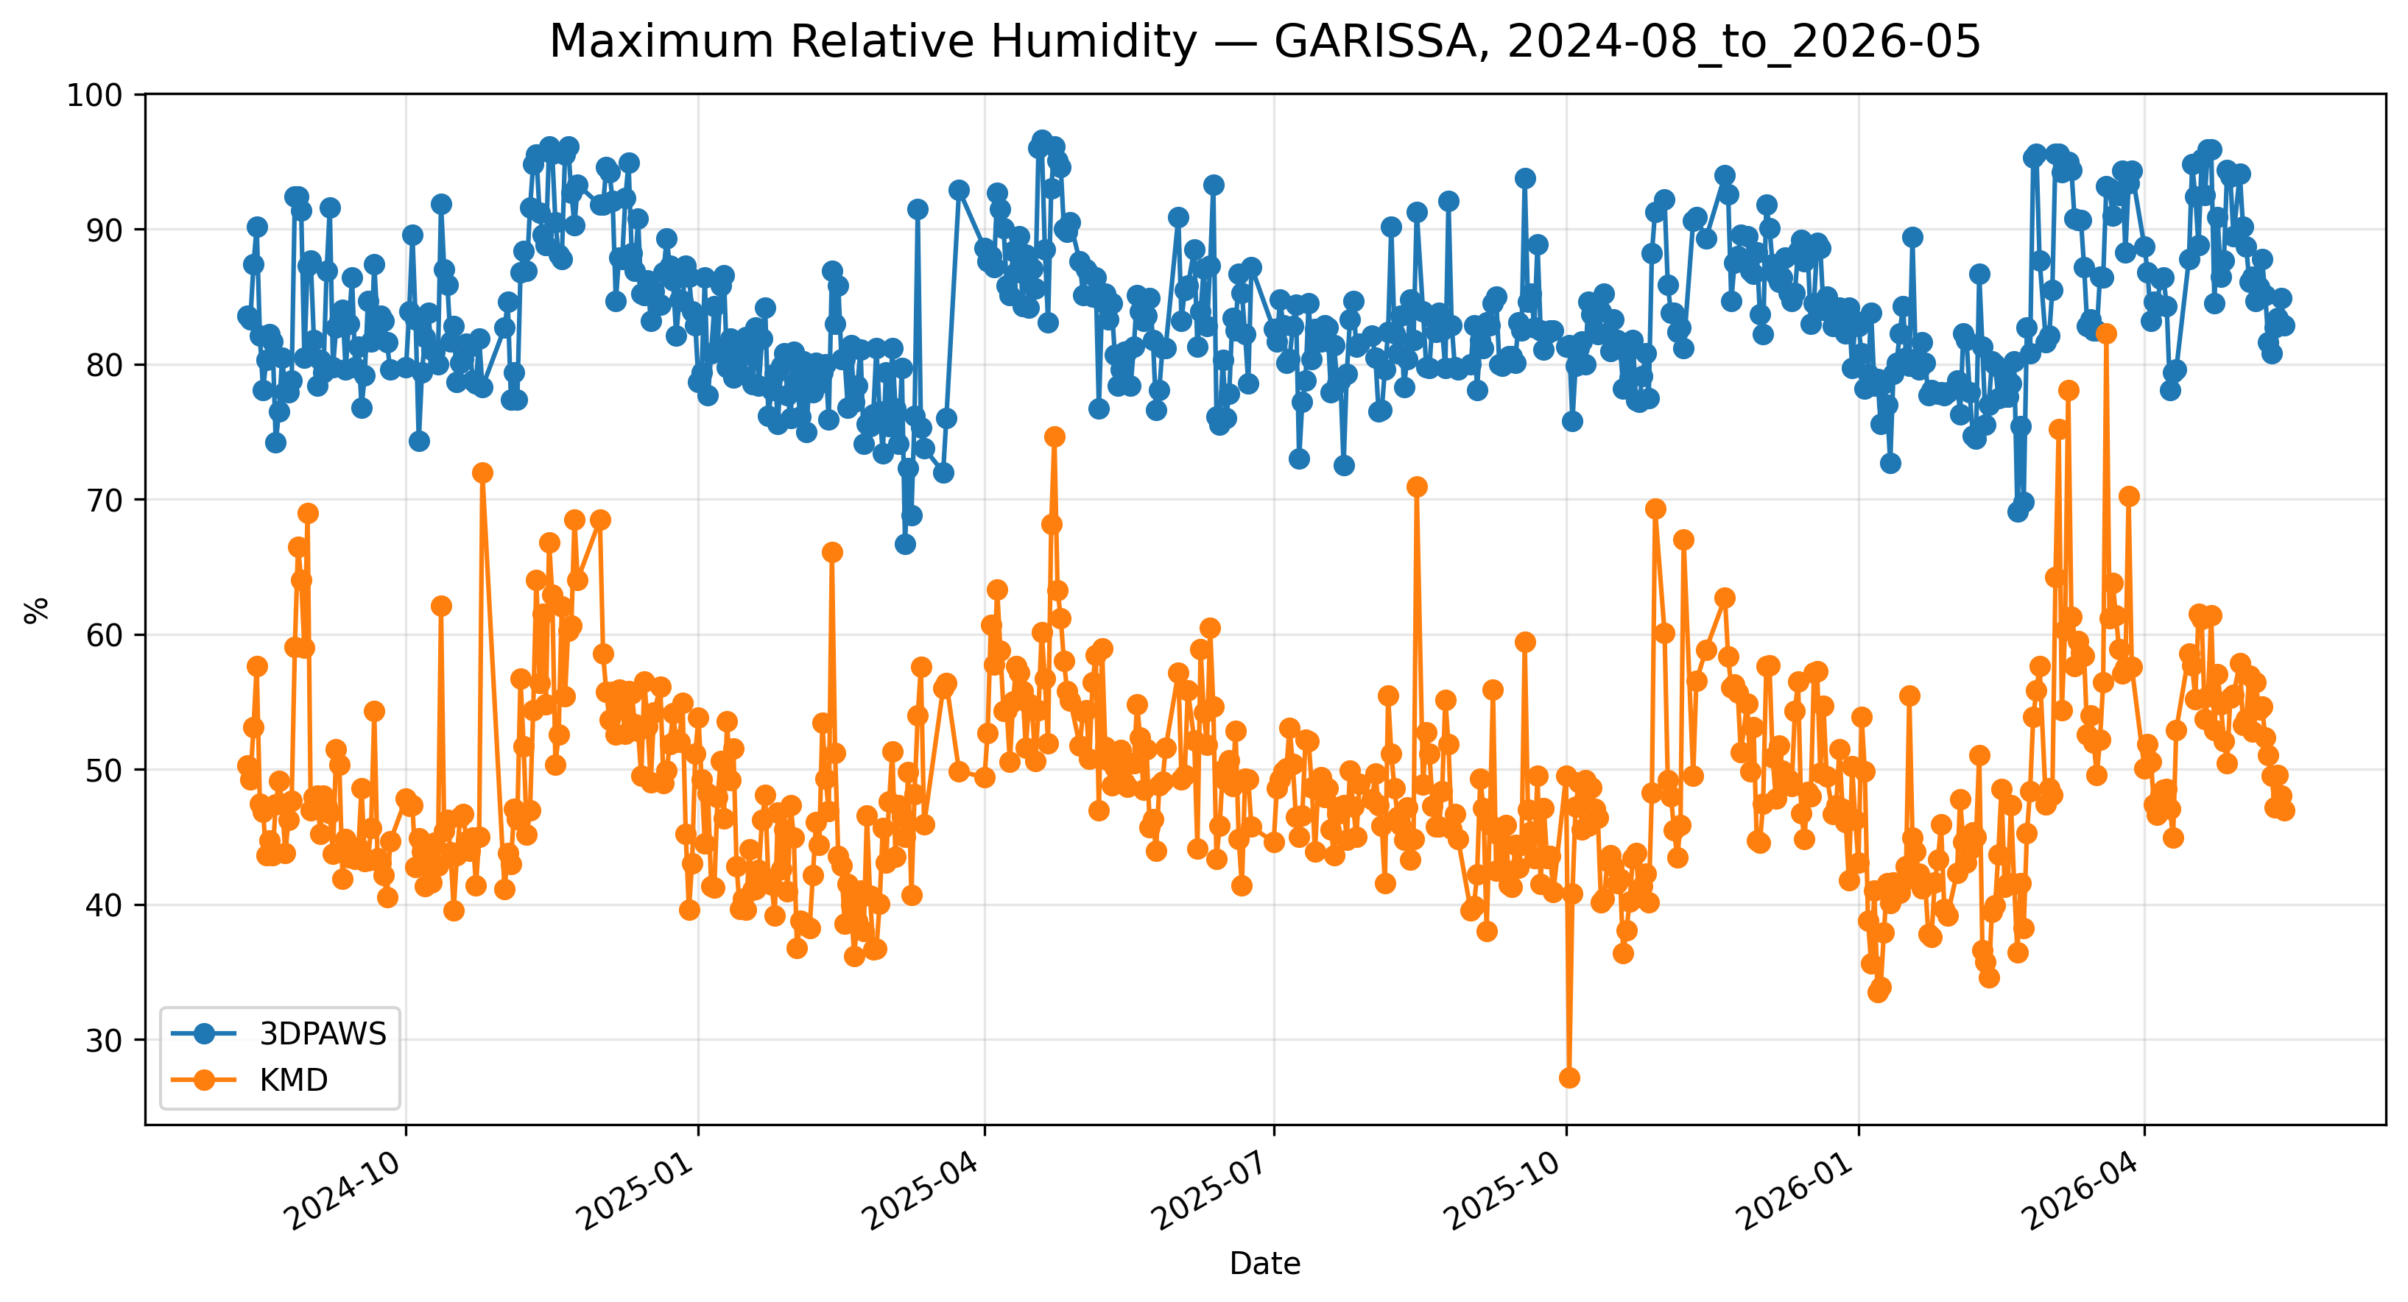
Figure 7.8: Time-series comparison of daily maximum relative humidity observations between 3DPAWS and KMD at GARISSA for 2024-08_to_2026-05.

Minimum Relative Humidity
Data status: HIGH QUALITY | Paired observations: 565 | Comparison missing: 77
Descriptive statistics
Statistic | 3DPAWS | KMD
Observations | 565 | 565
Mean | 37.595 | 49.150
Median | 37.400 | 48.200
Minimum | 19.800 | 27.170
Maximum | 71.100 | 82.280
Standard Deviation | 6.959 | 7.273
Variance | 48.432 | 52.897
Validation statistics
Metric | Value
Bias | -11.555 %
Mean Absolute Error (MAE) | 11.556 %
Root Mean Square Error (RMSE) | 12.235 %
Correlation coefficient (r) | 0.841
Coefficient of determination (R²) | 0.707
Performance assessment: Below Threshold
WMO requirement: 776
Criterion | Value
Goal | 0.500 %
Breakthrough | 2.500 %
Threshold | 5.000 %
Interpretation: The paired observations show strong linear agreement between 3DPAWS and KMD measurements (r = 0.841). The coefficient of determination was R² = 0.707. The mean bias was -11.555 %, indicating that the 3DPAWS observations were generally lower than the KMD observations. The mean absolute error was 11.556 %. The root mean square error was 12.235 %. Under the implemented performance assessment criteria, the parameter was classified as Below Threshold. The relatively high correlation indicates that 3D-PAWS successfully captured temporal humidity variability despite differences in absolute values.
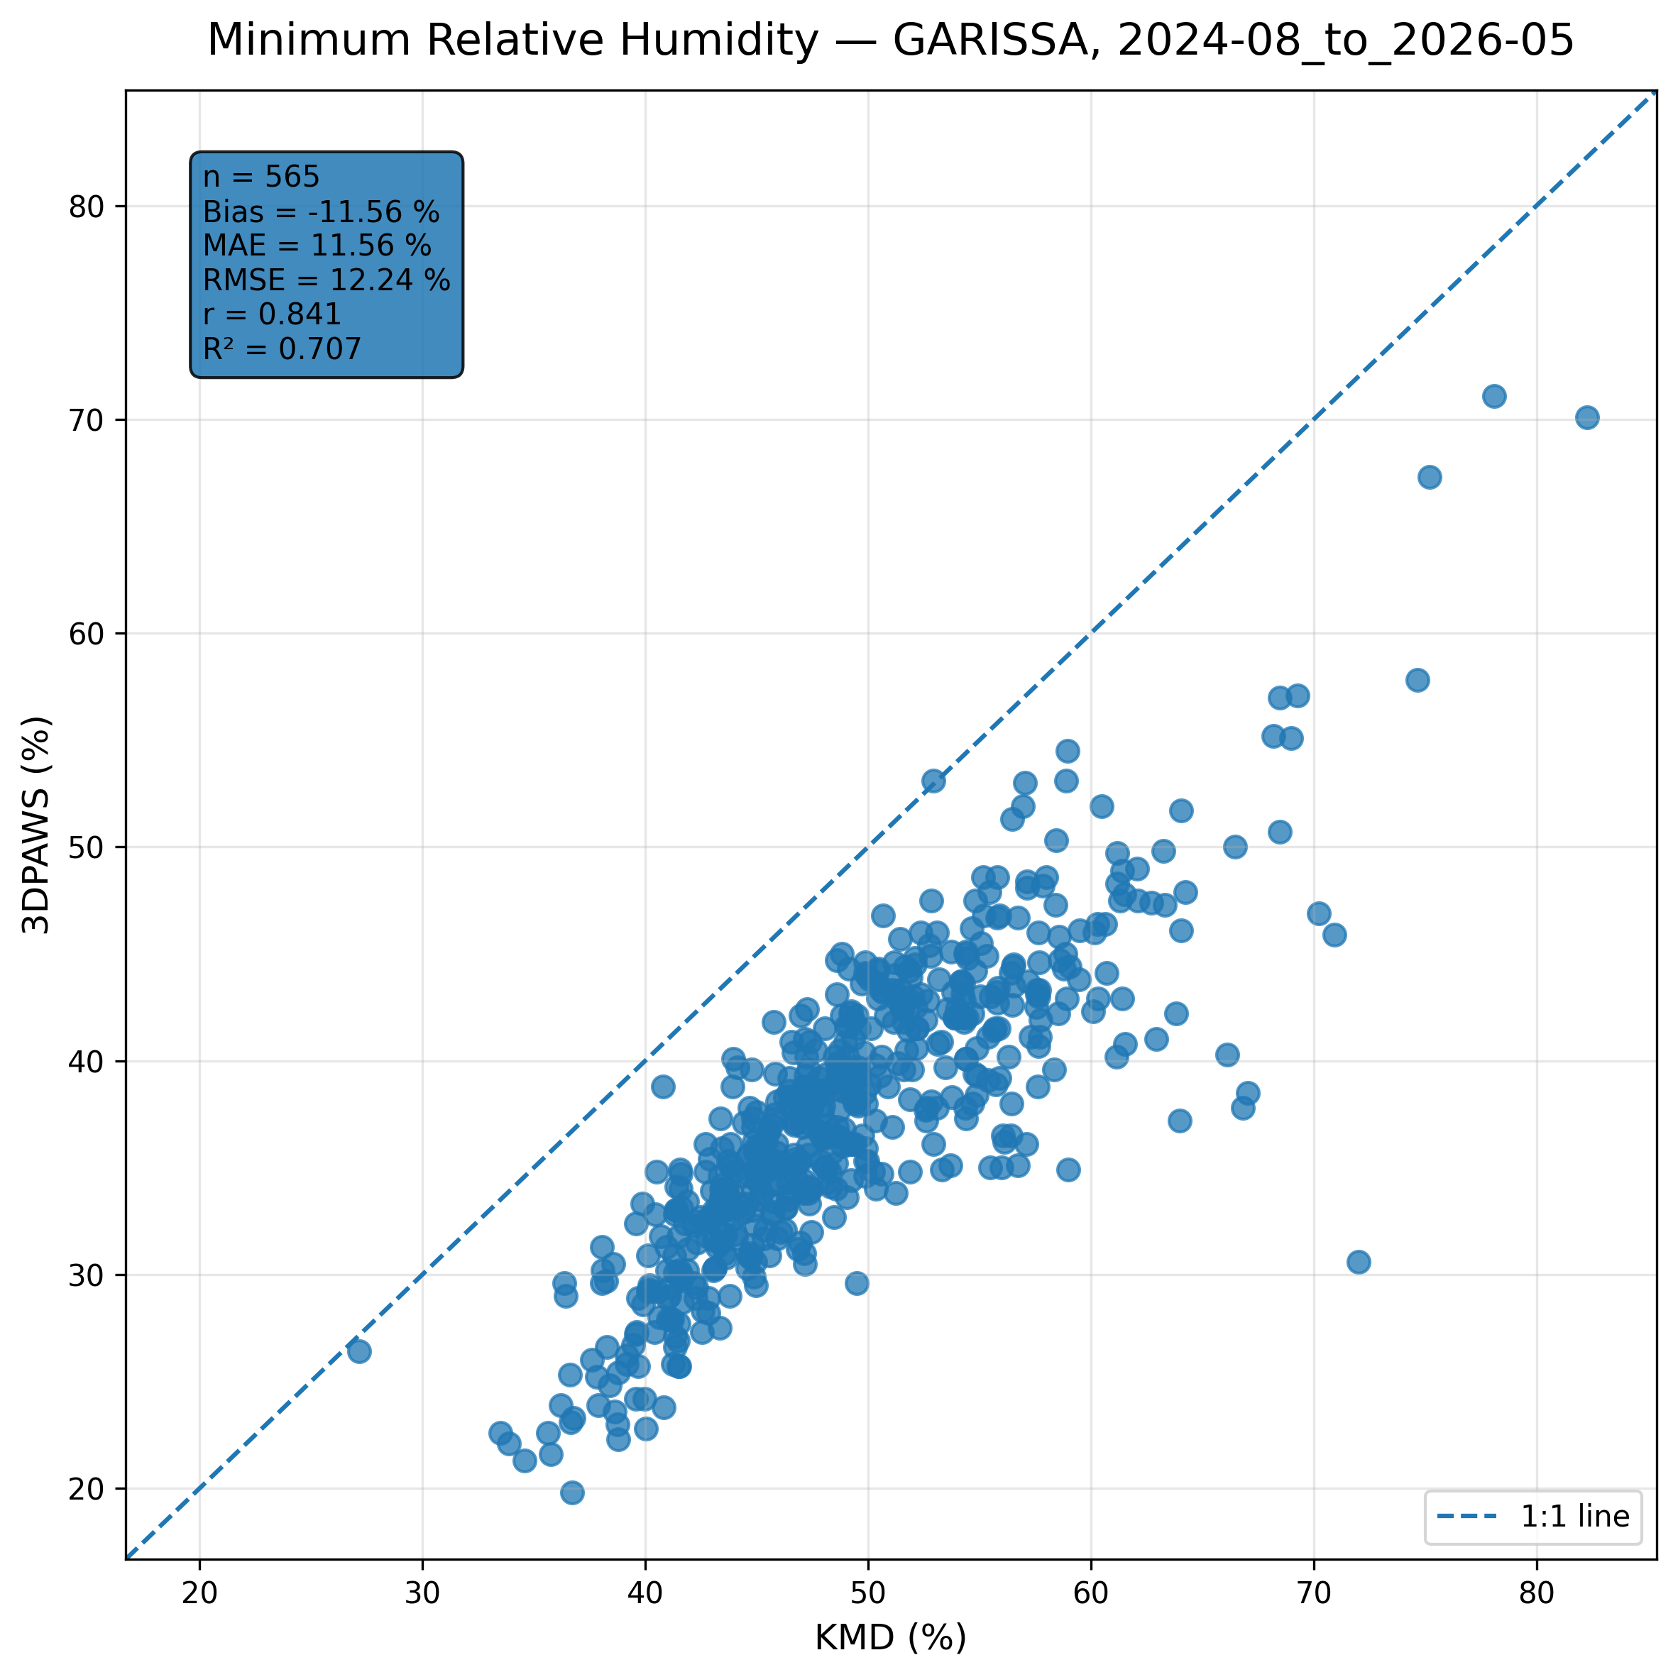
Figure 7.9: Scatter comparison of minimum relative humidity observations between 3DPAWS and KMD at GARISSA for 2024-08_to_2026-05.
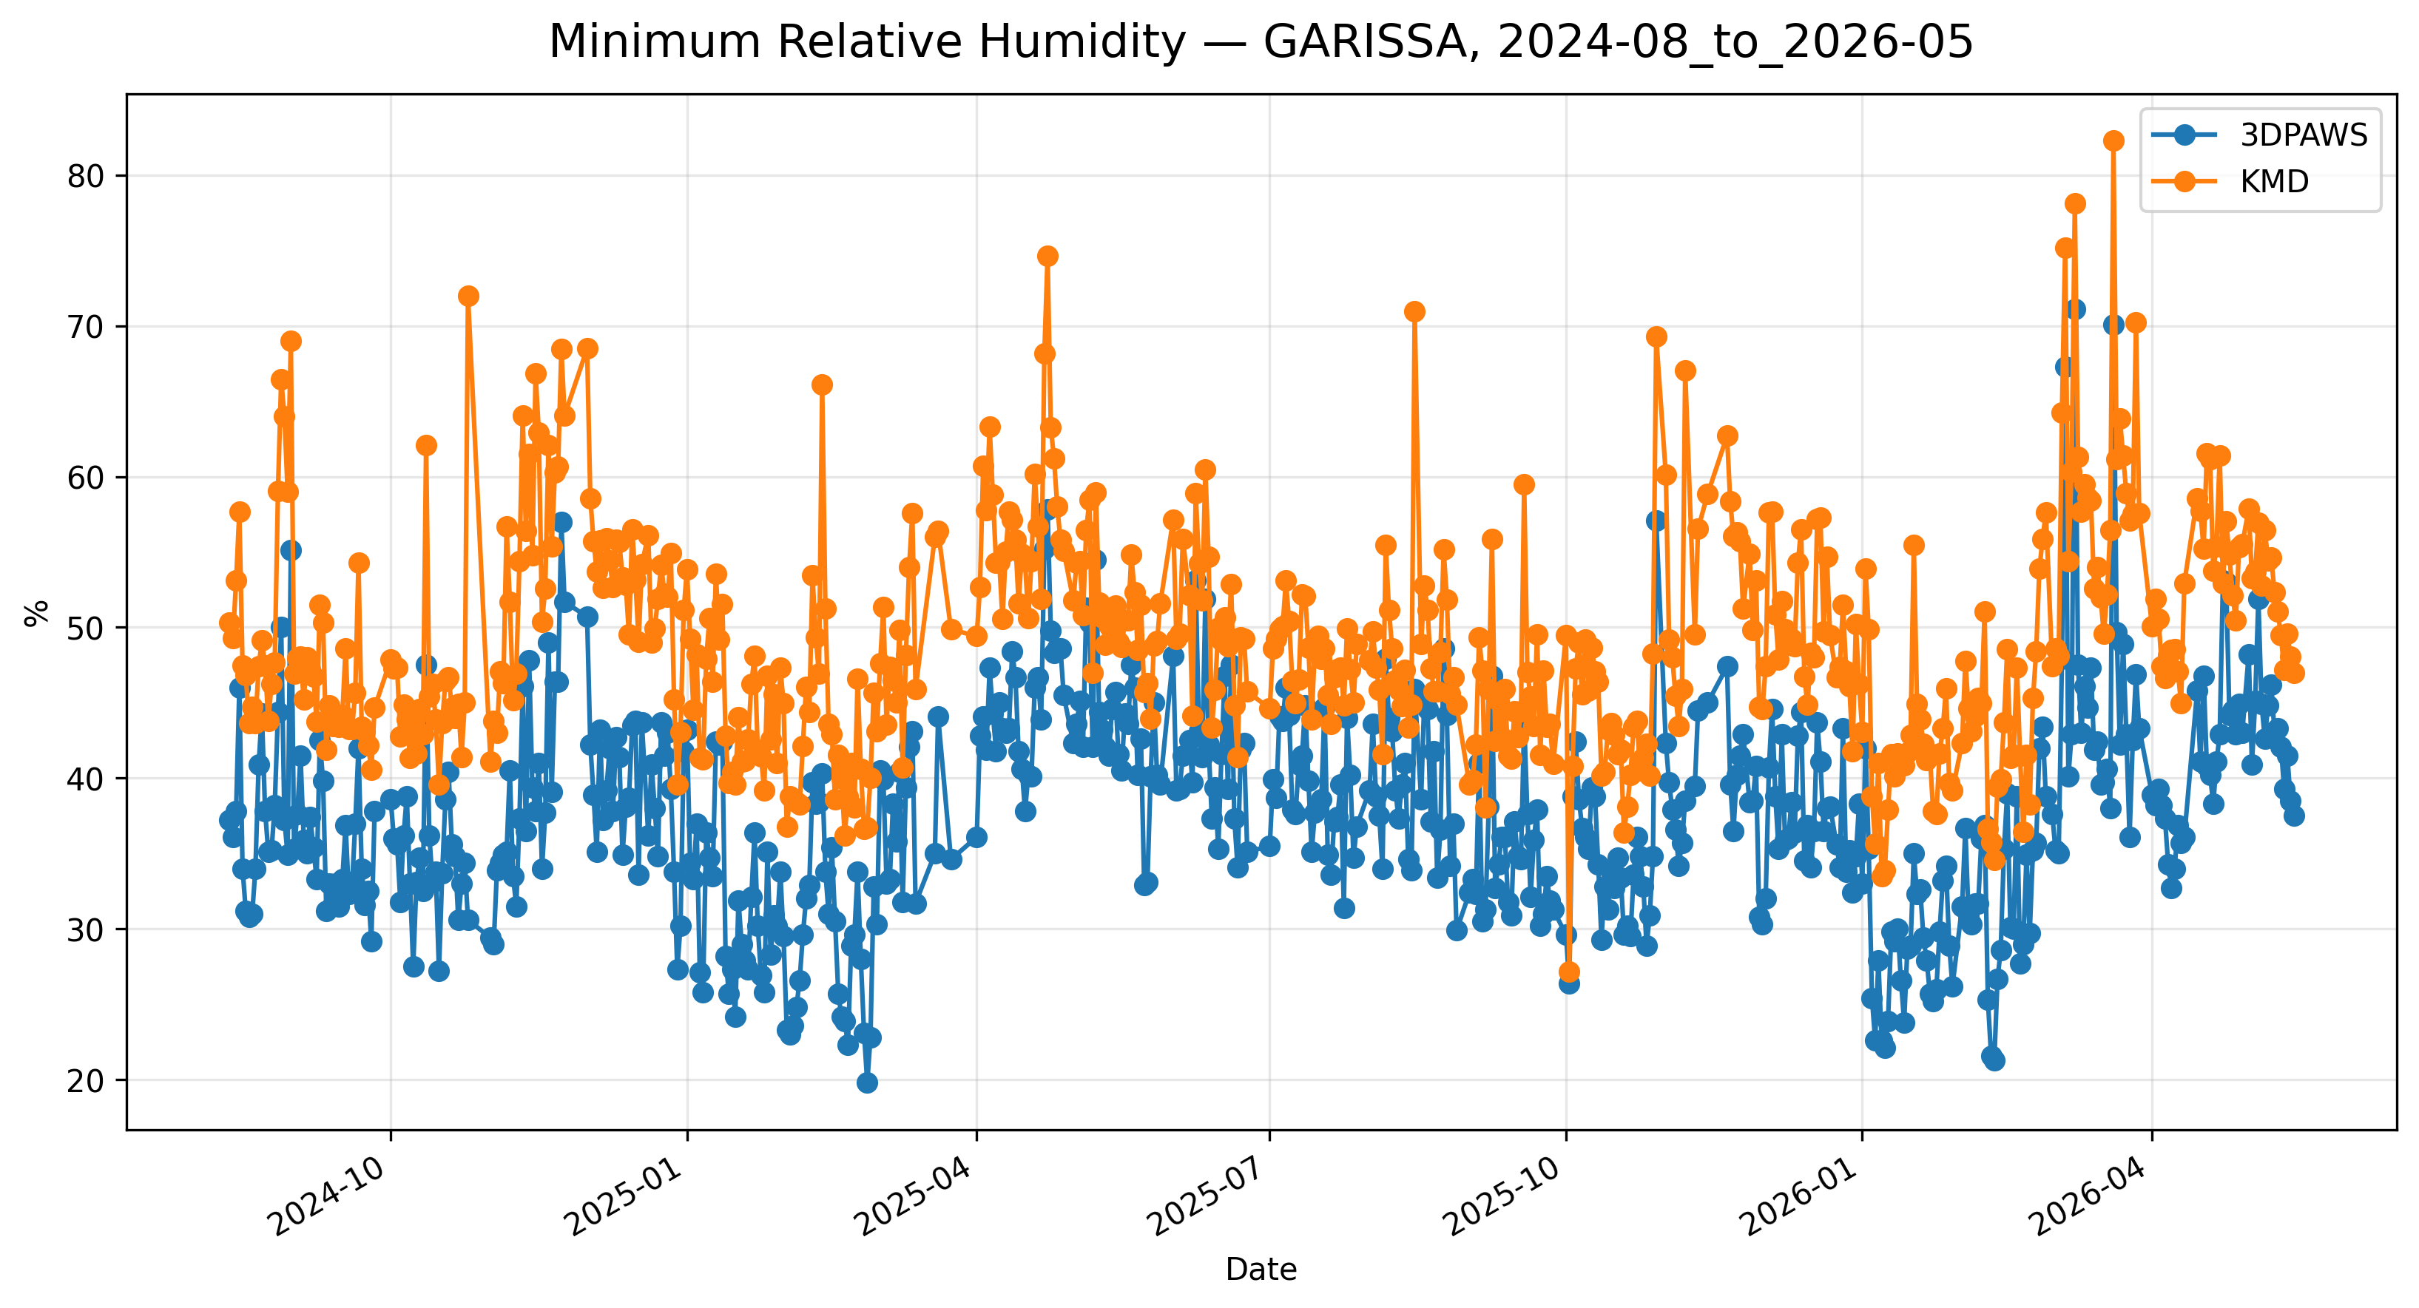
Figure 7.10: Time-series comparison of daily minimum relative humidity observations between 3DPAWS and KMD at GARISSA for 2024-08_to_2026-05.

Mean Relative Humidity
Data status: HIGH QUALITY | Paired observations: 565 | Comparison missing: 77
Descriptive statistics
Statistic | 3DPAWS | KMD
Observations | 565 | 565
Mean | 61.586 | 49.150
Median | 60.984 | 48.200
Minimum | 39.184 | 27.170
Maximum | 87.976 | 82.280
Standard Deviation | 7.193 | 7.273
Variance | 51.740 | 52.897
Validation statistics
Metric | Value
Bias | 12.436 %
Mean Absolute Error (MAE) | 12.531 %
Root Mean Square Error (RMSE) | 12.899 %
Correlation coefficient (r) | 0.888
Coefficient of determination (R²) | 0.788
Performance assessment: Below Threshold
WMO requirement: 776
Criterion | Value
Goal | 0.500 %
Breakthrough | 2.500 %
Threshold | 5.000 %
Interpretation: The paired observations show strong linear agreement between 3DPAWS and KMD measurements (r = 0.888). The coefficient of determination was R² = 0.788. The mean bias was 12.436 %, indicating that the 3DPAWS observations were generally higher than the KMD observations. The mean absolute error was 12.531 %. The root mean square error was 12.899 %. Under the implemented performance assessment criteria, the parameter was classified as Below Threshold. The relatively high correlation indicates that 3D-PAWS successfully captured temporal humidity variability despite differences in absolute values.
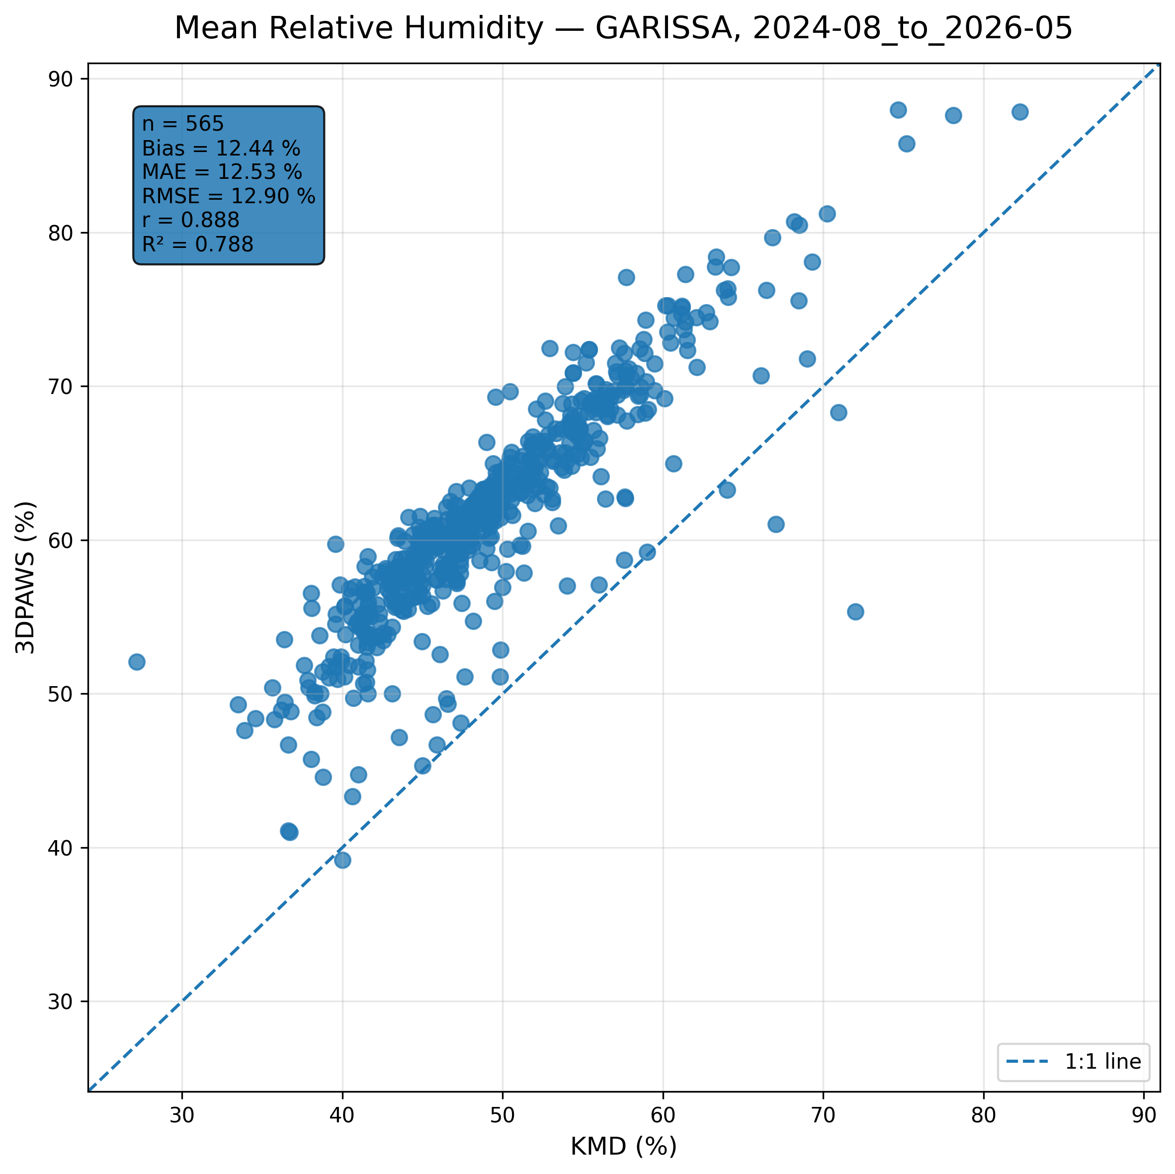
Figure 7.11: Scatter comparison of mean relative humidity observations between 3DPAWS and KMD at GARISSA for 2024-08_to_2026-05.
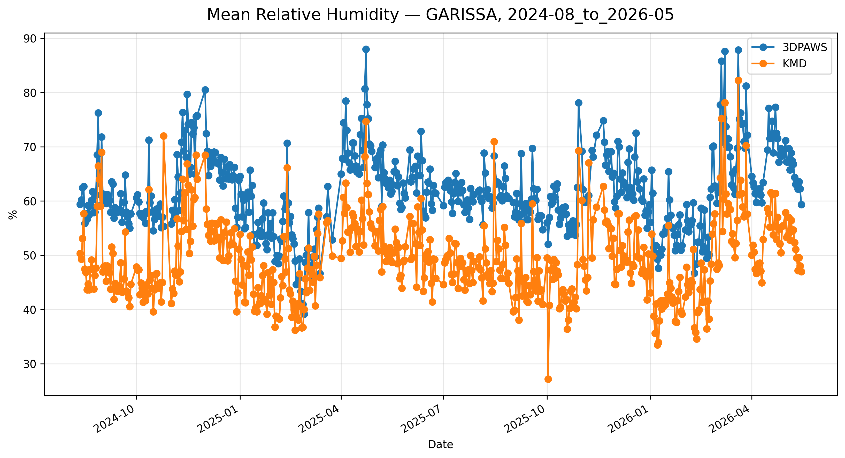
Figure 7.12: Time-series comparison of daily mean relative humidity observations between 3DPAWS and KMD at GARISSA for 2024-08_to_2026-05.

7.6 Pressure Results

Maximum Pressure
Data status: GOOD QUALITY | Paired observations: 567 | Comparison missing: 75
Descriptive statistics
Statistic | 3DPAWS | KMD
Observations | 567 | 567
Mean | 998.046 | 996.137
Median | 997.900 | 994.110
Minimum | 993.700 | 989.760
Maximum | 1002.700 | 1041.890
Standard Deviation | 1.970 | 7.502
Variance | 3.883 | 56.273
Validation statistics
Metric | Value
Bias | 1.909 hPa
Mean Absolute Error (MAE) | 4.769 hPa
Root Mean Square Error (RMSE) | 6.624 hPa
Correlation coefficient (r) | 0.671
Coefficient of determination (R²) | 0.451
Performance assessment: Below Threshold
WMO requirement: 250
Criterion | Value
Goal | 0.500 hPa
Breakthrough | 1.000 hPa
Threshold | 1.000 hPa
Interpretation: The paired observations show moderate linear agreement between 3DPAWS and KMD measurements (r = 0.671). The coefficient of determination was R² = 0.451. The mean bias was 1.909 hPa, indicating that the 3DPAWS observations were generally higher than the KMD observations. The mean absolute error was 4.769 hPa. The root mean square error was 6.624 hPa. Under the implemented performance assessment criteria, the parameter was classified as Below Threshold. Differences in pressure variability may be associated with elevation correction, sensor response characteristics, or local exposure conditions.
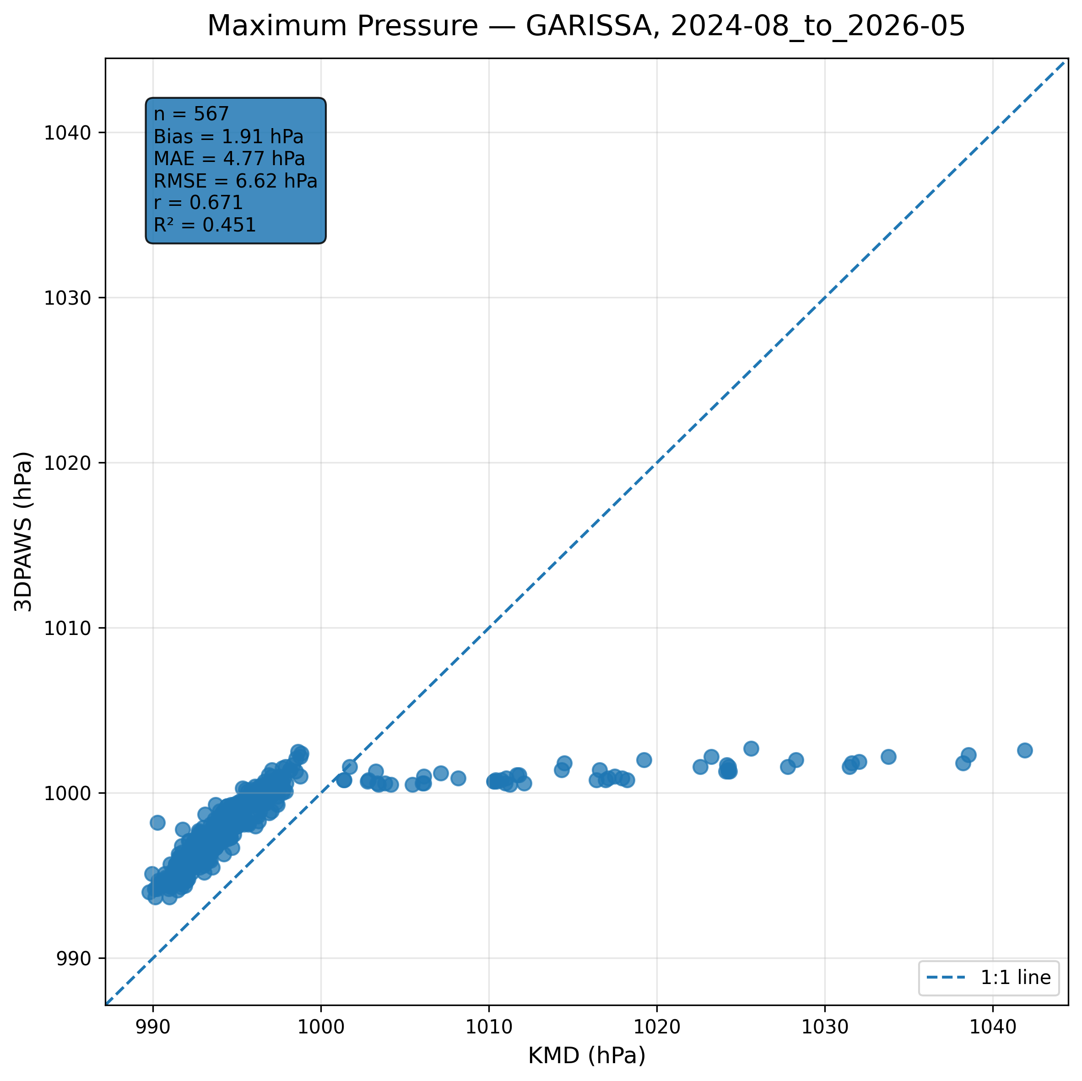
Figure 7.13: Scatter comparison of maximum pressure observations between 3DPAWS and KMD at GARISSA for 2024-08_to_2026-05.
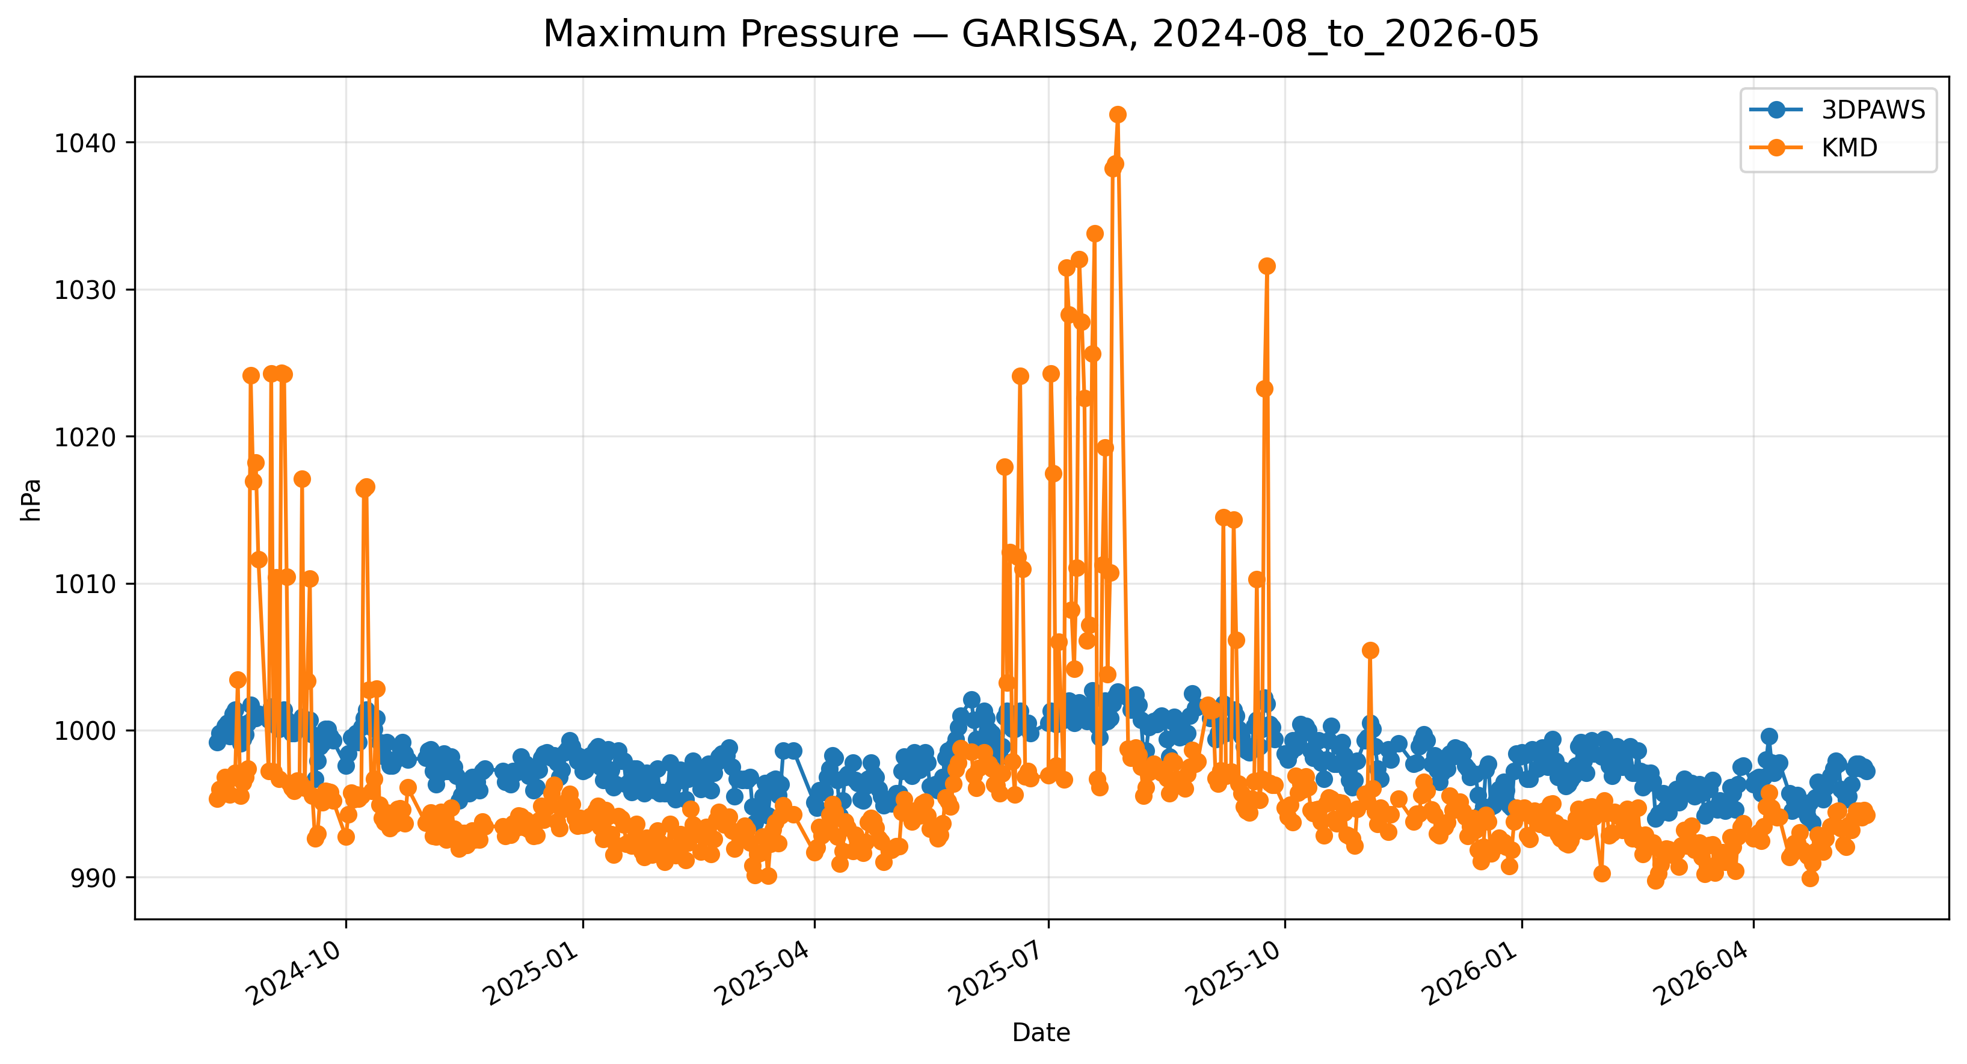
Figure 7.14: Time-series comparison of daily maximum pressure observations between 3DPAWS and KMD at GARISSA for 2024-08_to_2026-05.

Minimum Pressure
Data status: GOOD QUALITY | Paired observations: 567 | Comparison missing: 75
Descriptive statistics
Statistic | 3DPAWS | KMD
Observations | 567 | 567
Mean | 968.474 | 996.137
Median | 990.400 | 994.110
Minimum | 834.600 | 989.760
Maximum | 997.200 | 1041.890
Standard Deviation | 55.137 | 7.502
Variance | 3040.074 | 56.273
Validation statistics
Metric | Value
Bias | -27.663 hPa
Mean Absolute Error (MAE) | 27.668 hPa
Root Mean Square Error (RMSE) | 62.960 hPa
Correlation coefficient (r) | -0.131
Coefficient of determination (R²) | 0.017
Performance assessment: Below Threshold
WMO requirement: 250
Criterion | Value
Goal | 0.500 hPa
Breakthrough | 1.000 hPa
Threshold | 1.000 hPa
Interpretation: The paired observations show very weak linear agreement between 3DPAWS and KMD measurements (r = -0.131). The coefficient of determination was R² = 0.017. The mean bias was -27.663 hPa, indicating that the 3DPAWS observations were generally lower than the KMD observations. The mean absolute error was 27.668 hPa. The root mean square error was 62.960 hPa. Under the implemented performance assessment criteria, the parameter was classified as Below Threshold. Differences in pressure variability may be associated with elevation correction, sensor response characteristics, or local exposure conditions.
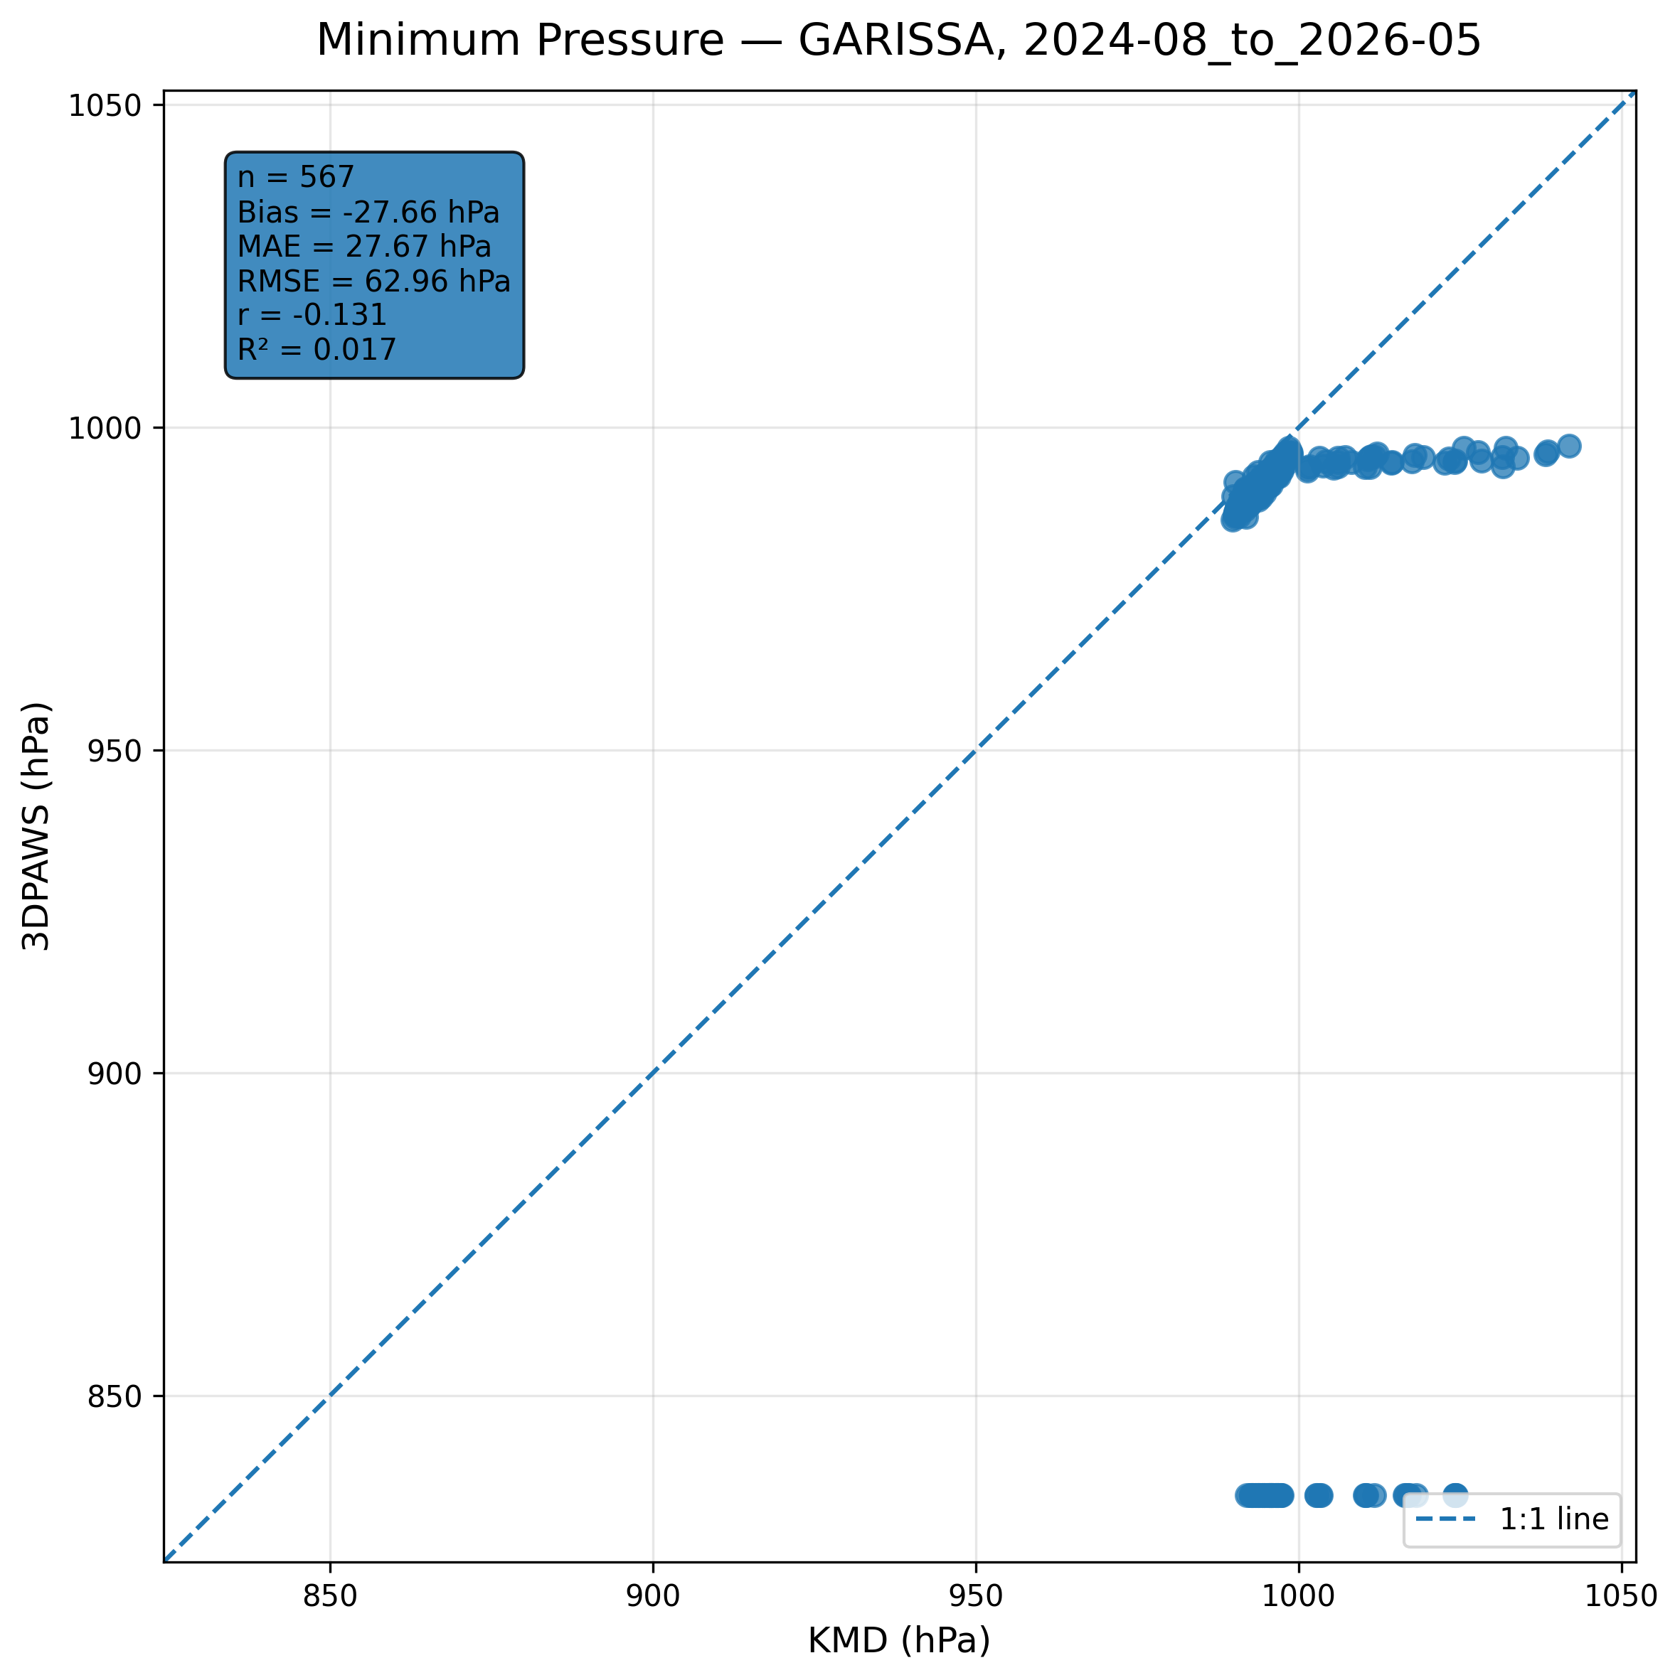
Figure 7.15: Scatter comparison of minimum pressure observations between 3DPAWS and KMD at GARISSA for 2024-08_to_2026-05.
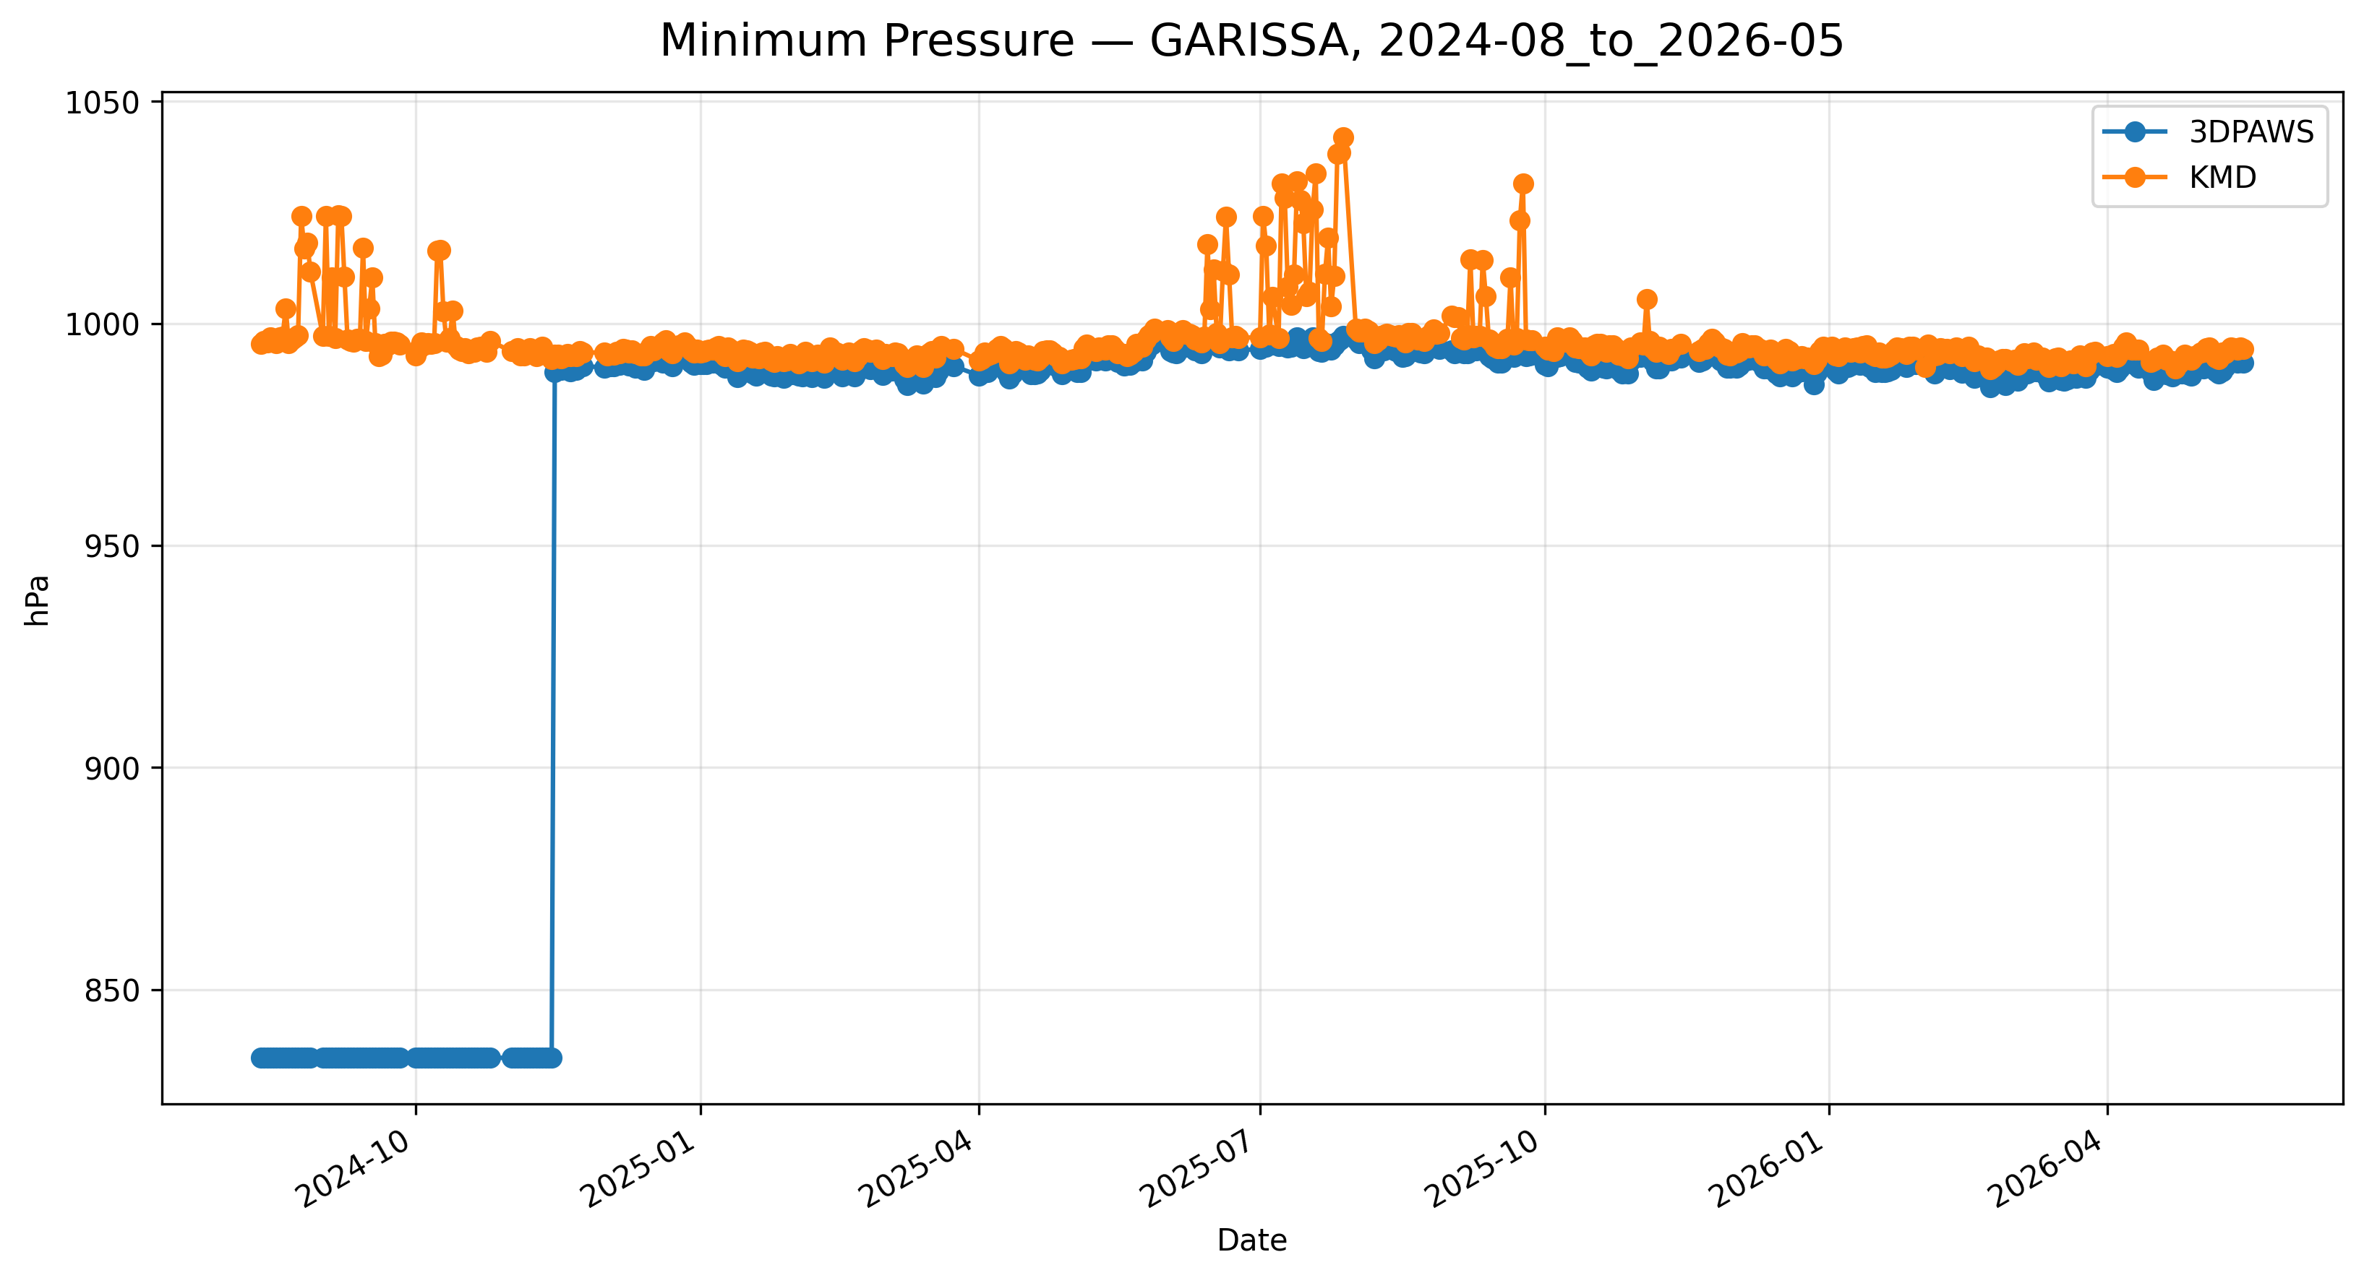
Figure 7.16: Time-series comparison of daily minimum pressure observations between 3DPAWS and KMD at GARISSA for 2024-08_to_2026-05.

Mean Pressure
Data status: GOOD QUALITY | Paired observations: 567 | Comparison missing: 75
Descriptive statistics
Statistic | 3DPAWS | KMD
Observations | 567 | 567
Mean | 994.776 | 996.137
Median | 994.552 | 994.110
Minimum | 989.747 | 989.760
Maximum | 1000.293 | 1041.890
Standard Deviation | 2.081 | 7.502
Variance | 4.331 | 56.273
Validation statistics
Metric | Value
Bias | -1.361 hPa
Mean Absolute Error (MAE) | 2.199 hPa
Root Mean Square Error (RMSE) | 6.420 hPa
Correlation coefficient (r) | 0.678
Coefficient of determination (R²) | 0.459
Performance assessment: Below Threshold
WMO requirement: 250
Criterion | Value
Goal | 0.500 hPa
Breakthrough | 1.000 hPa
Threshold | 1.000 hPa
Interpretation: The paired observations show moderate linear agreement between 3DPAWS and KMD measurements (r = 0.678). The coefficient of determination was R² = 0.459. The mean bias was -1.361 hPa, indicating that the 3DPAWS observations were generally lower than the KMD observations. The mean absolute error was 2.199 hPa. The root mean square error was 6.420 hPa. Under the implemented performance assessment criteria, the parameter was classified as Below Threshold. Differences in pressure variability may be associated with elevation correction, sensor response characteristics, or local exposure conditions.
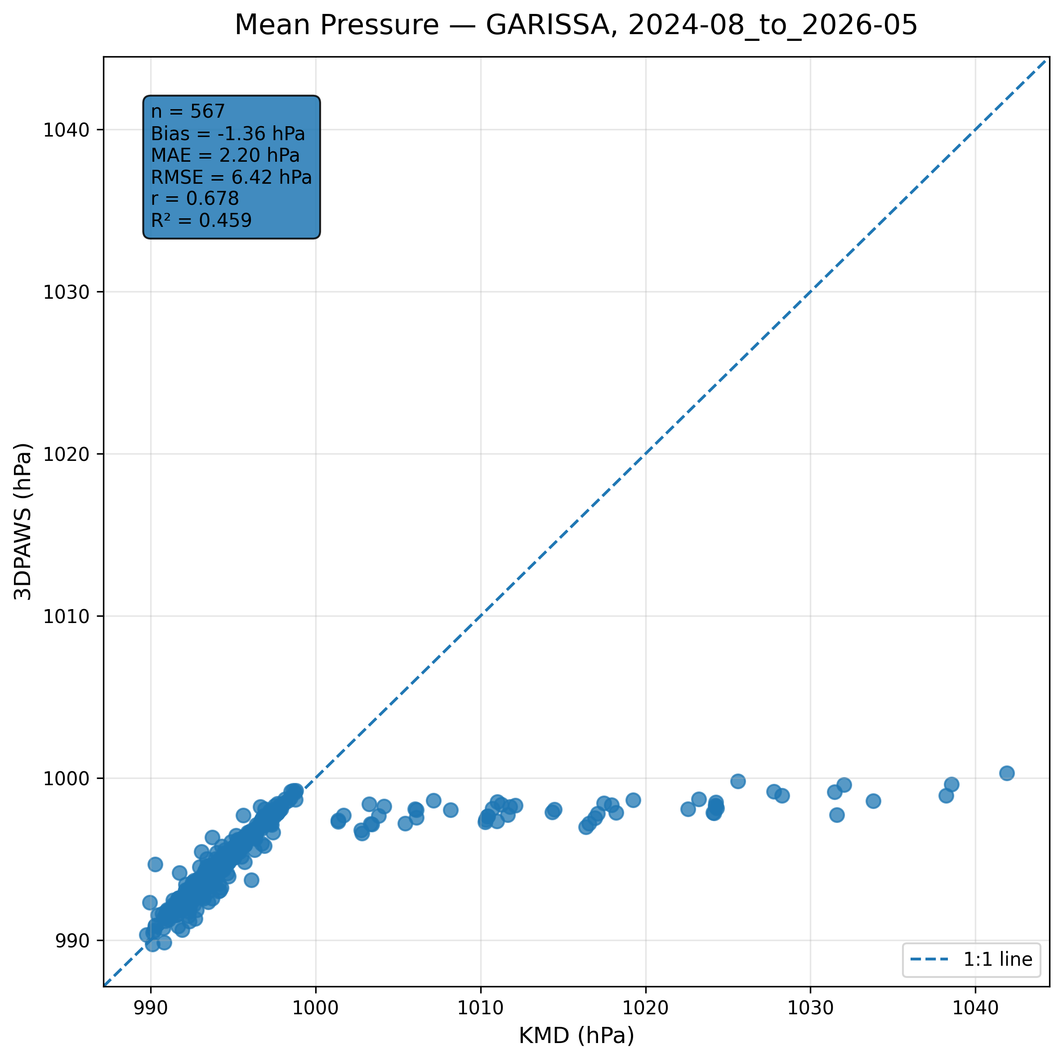
Figure 7.17: Scatter comparison of mean pressure observations between 3DPAWS and KMD at GARISSA for 2024-08_to_2026-05.
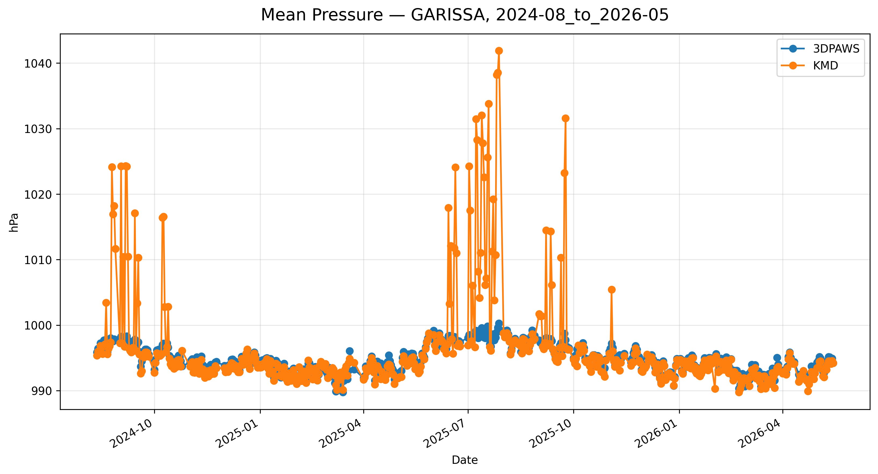
Figure 7.18: Time-series comparison of daily mean pressure observations between 3DPAWS and KMD at GARISSA for 2024-08_to_2026-05.

7.7 Rainfall Results

Daily Rainfall (Rain Gauge 1)
Data status: AVAILABLE | Paired observations: 636 | Comparison missing: 6
Descriptive statistics
Statistic | 3DPAWS | KMD
Observations | 636 | 636
Mean | 0.891 | 1.232
Median | 0.000 | 0.000
Minimum | 0.000 | 0.000
Maximum | 99.000 | 82.900
Standard Deviation | 5.851 | 6.328
Variance | 34.231 | 40.040
Validation statistics
Metric | Value
Bias | -0.340 mm
Mean Absolute Error (MAE) | 1.155 mm
Root Mean Square Error (RMSE) | 5.885 mm
Correlation coefficient (r) | 0.536
Coefficient of determination (R²) | 0.288
Performance assessment: Below Threshold
WMO requirement: 244
Criterion | Value
Goal | 0.500 mm
Breakthrough | 2.000 mm
Threshold | 5.000 mm
Interpretation: The paired observations show moderate linear agreement between 3DPAWS and KMD measurements (r = 0.536). The coefficient of determination was R² = 0.288. The mean bias was -0.340 mm, indicating that the 3DPAWS observations were generally lower than the KMD observations. The mean absolute error was 1.155 mm. The root mean square error was 5.885 mm. Under the implemented performance assessment criteria, the parameter was classified as Below Threshold. Rainfall comparison should consider the event-based nature of precipitation and possible spatial variability between gauges.
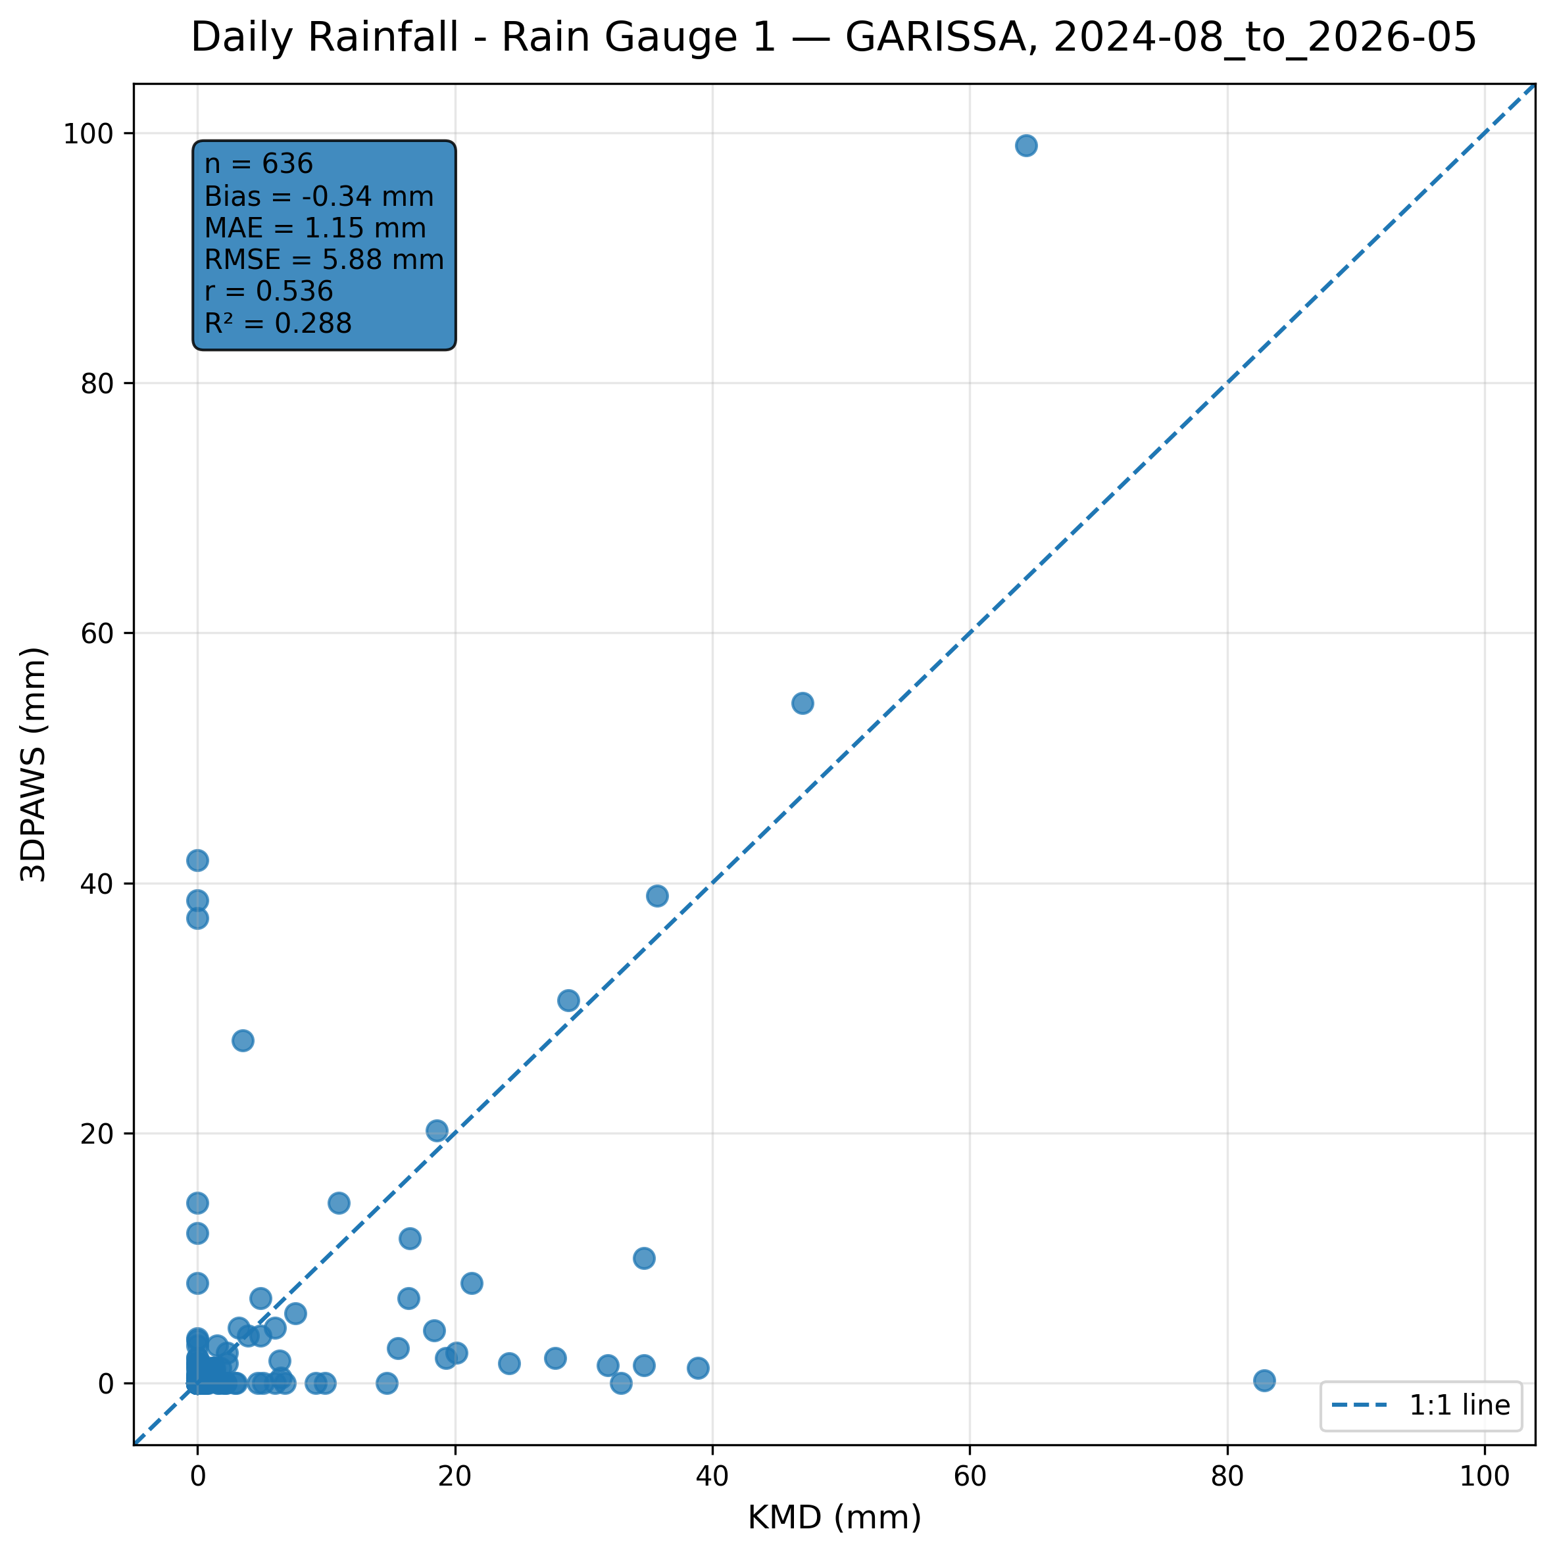
Figure 7.19: Scatter comparison of daily rainfall (rain gauge 1) observations between 3DPAWS and KMD at GARISSA for 2024-08_to_2026-05.
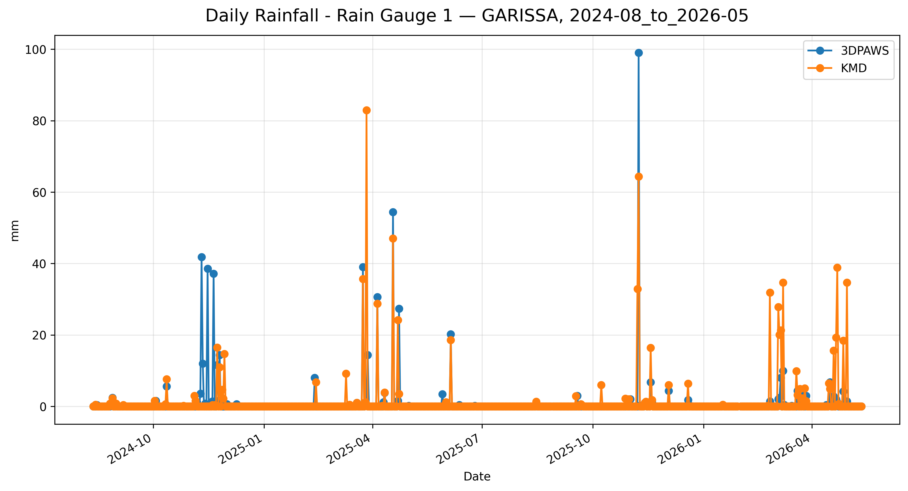
Figure 7.20: Time-series comparison of daily daily rainfall (rain gauge 1) observations between 3DPAWS and KMD at GARISSA for 2024-08_to_2026-05.

Daily Rainfall (Rain Gauge 2)
Data status: AVAILABLE | Paired observations: 636 | Comparison missing: 6
Descriptive statistics
Statistic | 3DPAWS | KMD
Observations | 636 | 636
Mean | 0.292 | 1.232
Median | 0.000 | 0.000
Minimum | 0.000 | 0.000
Maximum | 47.600 | 82.900
Standard Deviation | 2.973 | 6.328
Variance | 8.841 | 40.040
Validation statistics
Metric | Value
Bias | -0.940 mm
Mean Absolute Error (MAE) | 1.412 mm
Root Mean Square Error (RMSE) | 6.976 mm
Correlation coefficient (r) | 0.027
Coefficient of determination (R²) | 0.001
Performance assessment: Below Threshold
WMO requirement: 244
Criterion | Value
Goal | 0.500 mm
Breakthrough | 2.000 mm
Threshold | 5.000 mm
Interpretation: The paired observations show very weak linear agreement between 3DPAWS and KMD measurements (r = 0.027). The coefficient of determination was R² = 0.001. The mean bias was -0.940 mm, indicating that the 3DPAWS observations were generally lower than the KMD observations. The mean absolute error was 1.412 mm. The root mean square error was 6.976 mm. Under the implemented performance assessment criteria, the parameter was classified as Below Threshold. Rainfall comparison should consider the event-based nature of precipitation and possible spatial variability between gauges.
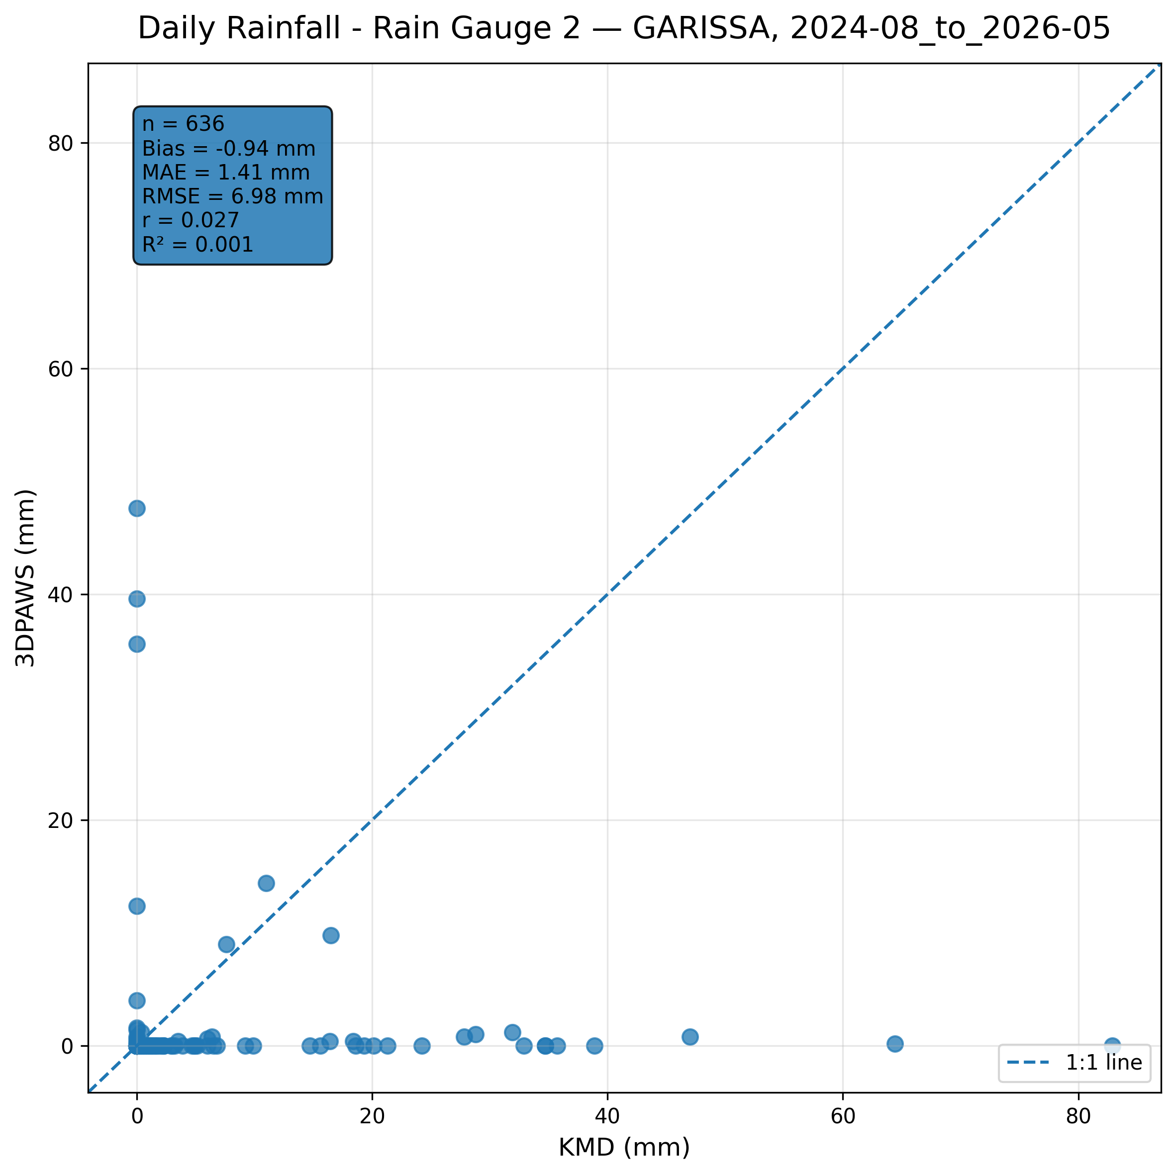
Figure 7.21: Scatter comparison of daily rainfall (rain gauge 2) observations between 3DPAWS and KMD at GARISSA for 2024-08_to_2026-05.
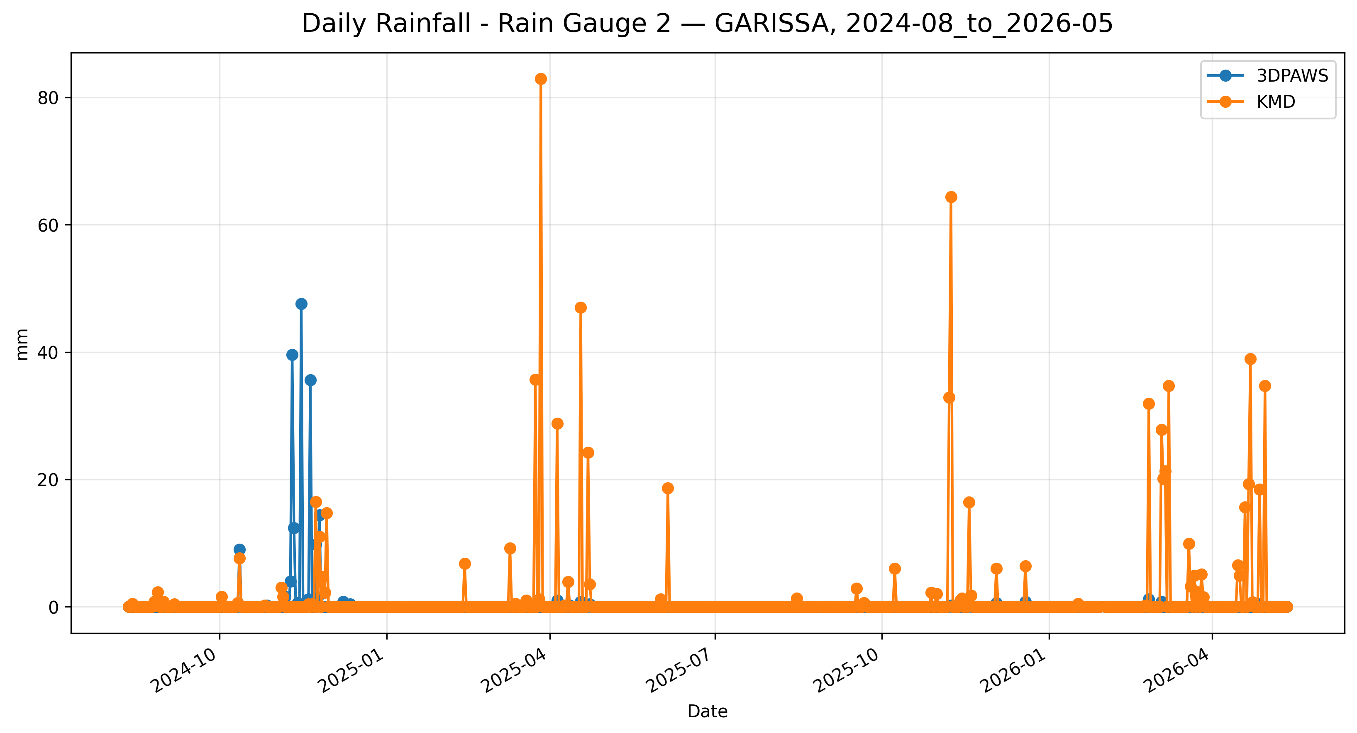
Figure 7.22: Time-series comparison of daily daily rainfall (rain gauge 2) observations between 3DPAWS and KMD at GARISSA for 2024-08_to_2026-05.

7.8 Overall Validation Performance Summary
Category | Parameter | Paired | Bias | MAE | RMSE | r | R² | Assessment | Data Status
Temperature | Maximum Temperature | 580 | 0.437 | 0.506 | 0.776 | 0.940 | 0.883 | Breakthrough | HIGH QUALITY
Temperature | Minimum Temperature | 585 | -0.560 | 0.717 | 0.967 | 0.820 | 0.672 | Breakthrough | HIGH QUALITY
Temperature | Mean Temperature | 570 | -0.804 | 0.993 | 1.135 | 0.856 | 0.733 | Threshold | HIGH QUALITY
Humidity | Maximum Relative Humidity | 565 | 34.479 | 34.479 | 34.903 | 0.670 | 0.448 | Below Threshold | HIGH QUALITY
Humidity | Minimum Relative Humidity | 565 | -11.555 | 11.556 | 12.235 | 0.841 | 0.707 | Below Threshold | HIGH QUALITY
Humidity | Mean Relative Humidity | 565 | 12.436 | 12.531 | 12.899 | 0.888 | 0.788 | Below Threshold | HIGH QUALITY
Pressure | Maximum Pressure | 567 | 1.909 | 4.769 | 6.624 | 0.671 | 0.451 | Below Threshold | GOOD QUALITY
Pressure | Minimum Pressure | 567 | -27.663 | 27.668 | 62.960 | -0.131 | 0.017 | Below Threshold | GOOD QUALITY
Pressure | Mean Pressure | 567 | -1.361 | 2.199 | 6.420 | 0.678 | 0.459 | Below Threshold | GOOD QUALITY
Rainfall | Daily Rainfall (Rain Gauge 1) | 636 | -0.340 | 1.155 | 5.885 | 0.536 | 0.288 | Below Threshold | AVAILABLE
Rainfall | Daily Rainfall (Rain Gauge 2) | 636 | -0.940 | 1.412 | 6.976 | 0.027 | 0.001 | Below Threshold | AVAILABLE
The summary table presents the statistical performance of the 3D-PAWS observations against the KMD reference dataset. Bias indicates the average systematic difference between the two systems, while MAE and RMSE describe the magnitude of observation differences. The correlation coefficient (r) and coefficient of determination (R²) describe the agreement in observed temporal variability.
Performance classifications should be interpreted together with the statistical indicators and environmental characteristics of each parameter. Parameters classified below the implemented threshold criteria may still demonstrate useful operational capability, particularly where strong temporal agreement is observed.

7.9 Overall Station Performance Assessment
The overall performance assessment for GARISSA was derived from the statistical comparison of individual meteorological parameters between the 3D-PAWS station and the KMD reference station. The assessment considers temporal agreement, magnitude of differences, observation coverage, and the parameter-specific performance criteria implemented in the validation toolkit.
The assessment is presented by meteorological parameter group. Within each group, the results are interpreted using correlation, error statistics, bias, and performance classification rather than relying on a single statistical indicator.

Temperature
Maximum Temperature demonstrated the strongest temporal agreement within the temperature parameter group, with r = 0.940.
Maximum Temperature recorded the lowest RMSE within the group (0.776 °C).
Maximum Temperature showed the smallest absolute bias within the group, with a bias of 0.437 °C.
Temperature observations demonstrated useful agreement with the KMD reference observations. Differences in correlation and error magnitude indicate that individual temperature statistics should be considered separately when assessing station performance.
Performance classification: Breakthrough, Threshold

Humidity
Mean Relative Humidity demonstrated the strongest temporal agreement within the humidity parameter group, with r = 0.888.
Minimum Relative Humidity recorded the lowest RMSE within the group (12.235 %).
Minimum Relative Humidity showed the smallest absolute bias within the group, with a bias of -11.555 %.
Relative humidity observations demonstrated temporal agreement with the KMD reference observations. Differences in absolute values should be considered when interpreting measurement agreement and performance classification. Further investigation may consider sensor calibration, exposure, and local environmental conditions.
Performance classification: Below Threshold

Pressure
Mean Pressure demonstrated the strongest temporal agreement within the pressure parameter group, with r = 0.678.
Mean Pressure recorded the lowest RMSE within the group (6.420 hPa).
Mean Pressure showed the smallest absolute bias within the group, with a bias of -1.361 hPa.
Atmospheric pressure observations showed differences in temporal agreement among the evaluated pressure statistics. Differences may be associated with elevation correction, pressure-reduction procedures, sensor response characteristics, and station exposure.
Performance classification: Below Threshold

Rainfall
Daily Rainfall (Rain Gauge 1) demonstrated the strongest temporal agreement within the rainfall parameter group, with r = 0.536.
Daily Rainfall (Rain Gauge 1) recorded the lowest RMSE within the group (5.885 mm).
Daily Rainfall (Rain Gauge 1) showed the smallest absolute bias within the group, with a bias of -0.340 mm.
Rainfall observations demonstrated the capability of the 3D-PAWS rain gauge system to capture rainfall occurrence and event variability. Differences in rainfall magnitude should be interpreted in relation to precipitation spatial variability and differences between the 3D-PAWS and KMD rain-gauge systems.
Performance classification: Below Threshold

7.10 Key Findings
The validation assessment conducted at GARISSA demonstrated that the 3D-PAWS system reproduced meaningful temporal variability in several meteorological parameters when compared with the KMD reference observations.
- Temperature performance was strongest for Maximum Temperature, which recorded the highest temperature correlation at r = 0.940. Maximum Temperature also recorded the lowest temperature RMSE of 0.776 °C. The smallest absolute temperature bias was observed for Maximum Temperature, at 0.437 °C.
- Relative humidity showed the strongest temporal agreement for Mean Relative Humidity, with r = 0.888 and R² = 0.788. The parameter assessments were Below Threshold under the implemented criteria. The results therefore indicate the degree of temporal reproduction achieved by the 3D-PAWS observations, while absolute differences should be considered when interpreting compliance with the applicable performance criteria.
- Atmospheric pressure showed the weakest temporal agreement among the evaluated parameter groups. The lowest pressure correlation was observed for Minimum Pressure, at r = -0.131. Mean Pressure showed the closest agreement in absolute magnitude, with a bias of -1.361 hPa and an MAE of 2.199 hPa. These results highlight pressure reduction and elevation-correction procedures as areas requiring further evaluation.
- Rainfall observations demonstrated temporal agreement with the KMD reference observations, with Daily Rainfall (Rain Gauge 1) recording the highest rainfall correlation at r = 0.536. Differences in rainfall magnitude should nevertheless be interpreted considering precipitation spatial variability and differences between the 3D-PAWS and KMD rain-gauge systems.
- Under the performance criteria implemented in the validation toolkit, the assessment distribution was Below Threshold: 8, Breakthrough: 2, Threshold: 1. These classifications describe compliance with the implemented statistical criteria and should not be interpreted independently of temporal agreement, error magnitude, observation coverage, and the intended operational use of each parameter.
- Parameter-level paired-observation coverage ranged from 88.0% for Maximum Relative Humidity to 99.1% for Daily Rainfall (Rain Gauge 1). These coverage differences should be considered when interpreting parameter-level statistical results.
Overall, the GARISSA validation results demonstrate that 3D-PAWS was able to reproduce meaningful temporal variability across several meteorological parameters, particularly relative humidity, rainfall, and temperature. However, strong temporal agreement did not consistently translate into compliance with the implemented accuracy thresholds, particularly for relative humidity and atmospheric pressure. These findings indicate the potential of 3D-PAWS as a cost-effective approach for meteorological observation network densification, while highlighting the need for continued sensor calibration, refinement of pressure-reduction and elevation-correction procedures, further development of quality-control procedures, and evaluation across additional stations and environmental conditions before wider operational deployment.

